Software Project Management

UNIT-I
Conventional Software Management: The waterfall Model, Conventional Software Management Performance,
Evolution of Software Economics: software Economics. Pragmatic Software Cost Estimation. Improving Software Economics: Reducing Software Product Size, Improving Software Processes, Improving Team Effectiveness, Improving Automation, Achieving Required Quality, Peer Inspections.

UNIT-II
Conventional and Modern Software Management: Principles of Conventional Software Engineering, Principles of Modern Software Management, Transitioning to an interactive Process.
Life Cycle Phases: Engineering and Production Stages Inception, Elaboration, Construction, Transition phases.

UNIT-III
Artifacts of the Process: The Artifact Sets. Management Artifacts, Engineering Artifacts, Programmatic Artifacts.
Model Based Software Architectures: A Management Perspective and Technical Perspective.

UNIT-IV
Flows of the Process: Software Process Workflows. Inter Trans Workflows.
Checkpoints of the Process: Major Mile Stones, Minor Milestones, Periodic Status Assessments.
Interactive Process Planning: Work Breakdown Structures, Planning Guidelines, Cost and Schedule Estimating. Interaction Planning Process, Pragmatic Planning.

UNIT-V
Project Organizations and Responsibilities: Line-of-Business Organizations, Project Organizations, and Evolution of Organizations.
Process Automation: Building Blocks, the Project Environment.
Project Control and Process Instrumentation: Server Care Metrics, Management Indicators, Quality Indicators, Life Cycle Expectations Pragmatic Software

TEXT BOOKS:

- Walker Rayce, “Software Project Management”, 1998, PEA.
- Henrey, “Software Project Management”, Pearson.

Reference Books:

- Richard H.Thayer.” Software Engineering Project Management”, 1997, IEEE Computer Society.
- Shere K.D.: “Software Engineering and Management”, 1998, PHI.
- S.A. Kelkar, “Software Project Management: A Concise Study”, PHI.
- Hughes Cotterell, “Software Project Management”, 2e, TMH. 88 5. Kaeron Conway, “Software Project Management from Concept to D

UNIT – I
Conventional Software Management: The waterfall model, conventional software Management performance.
Evolution of Software Economics: Software Economics, pragmatic software cost estimation.
Improving Software Economics: Reducing Software product size, improving software processes, improving team effectiveness, improving automation, Achieving required quality, peer inspections.

Conventional software management
Conventional software management practices are sound in theory, but practice is still tied to archaic (outdated) technology and techniques.
Conventional software economics provides a benchmark of performance for conventional software manage- ment principles.
The best thing about software is its flexibility: It can be programmed to do almost anything.
The worst thing about software is also its flexibility: The "almost anything" characteristic has made it difficult to plan, monitors, and control software development.
Three important analyses of the state of the software engineering industry are
  - Software development is still highly unpredictable. Only about 10% of software projects are delivered successfully within initial budget and schedule estimates.
  - Management discipline is more of a discriminator in success or failure than are technology advances.
  - The level of software scrap and rework is indicative of an immature process.
All three analyses reached the same general conclusion: The success rate for software projects is very low. The three analyses provide a good introduction to the magnitude of the software problem and the current norms for conventional software management performance.

THE WATERFALL MODEL
Most software engineering texts present the waterfall model as the source of the "conventional" software process.

IN THEORY
It provides an insightful and concise summary of conventional software management Three main primary points are
      - There are two essential steps common to the development of computer programs: analysis and

coding.
Waterfall Model part 1: The two basic steps to building a program.
Coding
Analysis
Analysis and coding both involve creative work that directly contributes to the usefulness of the end product.
      - In order to manage and control all of the intellectual freedom associated with software development, one must introduce several other "overhead" steps, including system requirements definition, software requirements definition, program design, and testing. These steps supplement the analysis and coding steps. Below Figure illustrates the resulting project profile and the basic steps in developing a large-scale program.

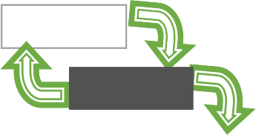
Requirement

Analysis
Coding
Operation
Testing
Design
      - The basic framework described in the waterfall model is risky and invites failure. The testing phase that occurs at the end of the development cycle is the first event for which timing, storage, input/output transfers, etc., are experienced as distinguished from analyzed. The resulting design changes are likely to be so disruptive that the software requirements upon which the design is based are likely violated. Either the requirements must be modified or a substantial design change is warranted.

Five necessary improvements for waterfall model are:-

- Program design comes first. Insert a preliminary program design phase between the software requirements generation phase and the analysis phase. By this technique, the program designer assures that the software will not fail because of storage, timing, and data flux (continuous change). As analysis proceeds in the succeeding phase, the program designer must impose on the analyst the storage, timing, and operational constraints in such a way that he senses the consequences. If the total resources to be applied are insufficient or if the embryonic(in an early stage of development) operational design is wrong, it will be recognized at this early stage and the iteration with requirements and preliminary design can be redone before final design, coding, and test commences. How is this program design procedure implemented?

The following steps are required:
Begin the design process with program designers, not analysts or programmers.
Design, define, and allocate the data processing modes even at the risk of being wrong. Allocate processing functions, design the database, allocate execution time, define interfaces and processing modes with the operating system, describe input and output processing, and define preliminary operating procedures.
Write an overview document that is understandable, informative, and current so that every worker on the project can gain an elemental understanding of the system.

- Document the design. The amount of documentation required on most software programs is quite a lot, certainly much more than most programmers, analysts, or program designers are willing to do if left to their own devices. Why do we need so much documentation? (1) Each designer must communicate with interfacing designers, managers, and possibly customers. (2) During early phases, the documentation is the design. (3) The real monetary value of documentation is to support later modifications by a separate test team, a separate maintenance team, and operations personnel who are not software literate.

- Do it twice. If a computer program is being developed for the first time, arrange matters so that the version finally delivered to the customer for operational deployment is actually the second version insofar as critical design/operations are concerned. Note that this is simply the entire process done in miniature, to a time scale

that is relatively small with respect to the overall effort. In the first version, the team must have a special broad competence where they can quickly sense trouble spots in the design, model them, model alternatives, forget the straightforward aspects of the design that aren't worth studying at this early point, and, finally, arrive at an error-free program.

- Plan, control, and monitor testing. Without question, the biggest user of project resources-manpower, computer time, and/or management judgment-is the test phase. This is the phase of greatest risk in terms of cost and schedule. It occurs at the latest point in the schedule, when backup alternatives are least available, if at all. The previous three recommendations were all aimed at uncovering and solving problems before entering the test phase. However, even after doing these things, there is still a test phase and there are still important things to be done, including: (1) employ a team of test specialists who were not responsible for the original design; (2) employ visual inspections to spot the obvious errors like dropped minus signs, missing factors of two, jumps to wrong addresses (do not use the computer to detect this kind of thing, it is too expensive); (3) test every logic path; (4) employ the final checkout on the target computer.

- Involve the customer. It is important to involve the customer in a formal way so that he has committed himself at earlier points before final delivery. There are three points following requirements definition where the insight, judgment, and commitment of the customer can bolster the development effort. These include a "preliminary software review" following the preliminary program design step, a sequence of "critical software design reviews" during program design, and a "final software acceptance review".

IN PRACTICE
Some software projects still practice the conventional software management approach.
It is useful to summarize the characteristics of the conventional process as it has typically been applied, which is not necessarily as it was intended. Projects destined for trouble frequently exhibit the following symptoms:

- Protracted integration and late design breakage.
- Late risk resolution.
- Requirements-driven functional decomposition.
- Adversarial (conflict or opposition) stakeholder relationships.
- Focus on documents and review meetings.

Protracted Integration and Late Design Breakage
For a typical development project that used a waterfall model management process, Figure 1-2 illustrates development progress versus time. Progress is defined as percent coded, that is, demonstrable in its target form.

The following sequence was common:
- Early success via paper designs and thorough (often too thorough) briefings.
- Commitment to code late in the life cycle.
- Integration nightmares (unpleasant experience) due to unforeseen implementation issues and interface ambiguities.
- Heavy budget and schedule pressure to get the system working.
- Late shoe-homing of no optimal fixes, with no time for redesign.
- A very fragile, unmentionable product delivered late.

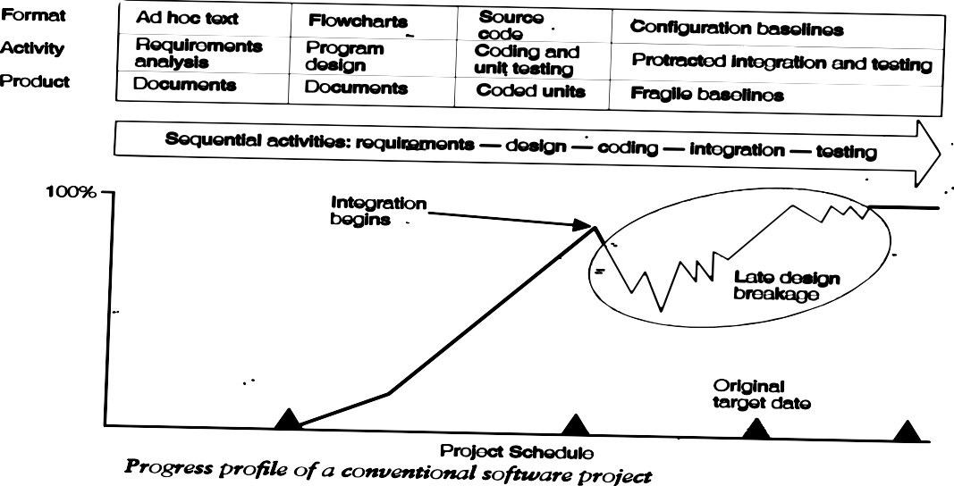
In the conventional model, the entire system was designed on paper, then implemented all at once, then integrated. Table 1-1 provides a typical profile of cost expenditures across the spectrum of software activities.

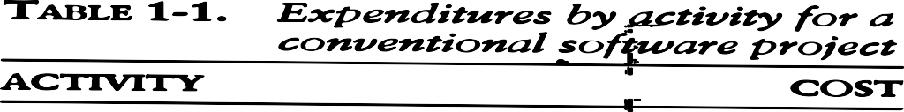

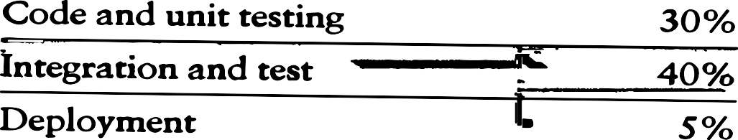
Late risk resolution A serious issue associated with the waterfall lifecycle was the lack of early risk resolution. Figure 1.3 illustrates a typical risk profile for conventional waterfall model projects. It includes four distinct periods of risk exposure, where risk is defined as the probability of missing a cost, schedule, feature, or quality goal. Early in the life cycle, as the requirements were being specified, the actual risk exposure was highly unpredictable.

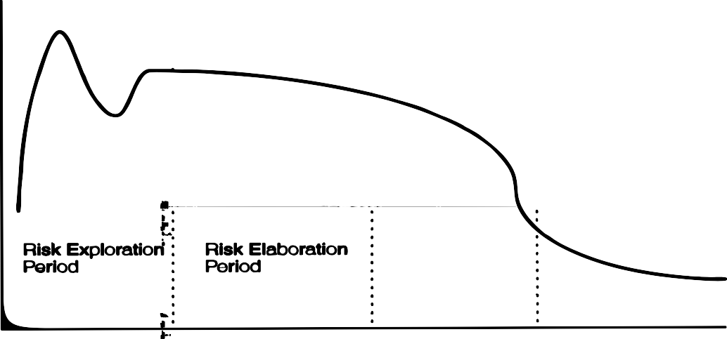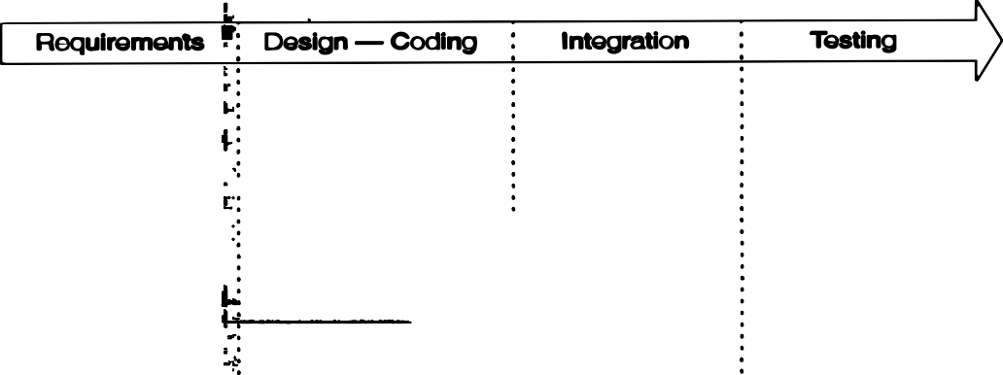Requirements-Driven Functional Decomposition: This approach depends on specifying requirements com- pletely and unambiguously before other development activities begin. It naively treats all requirements as equally important, and depends on those requirements remaining constant over the software development life cycle. These conditions rarely occur in the real world. Specification of requirements is a difficult and important part of the software development process.
Another property of the conventional approach is that the requirements were typically specified in a functional manner. Built into the classic waterfall process was the fundamental assumption that the software itself was decomposed into functions; requirements were then allocated to the resulting components. This decomposition was often very different from a decomposition based on object-oriented design and the use of existing components. Figure 1-4 illustrates the result of requirements-driven approaches: a software structure that is organized around the requirements specification structure.
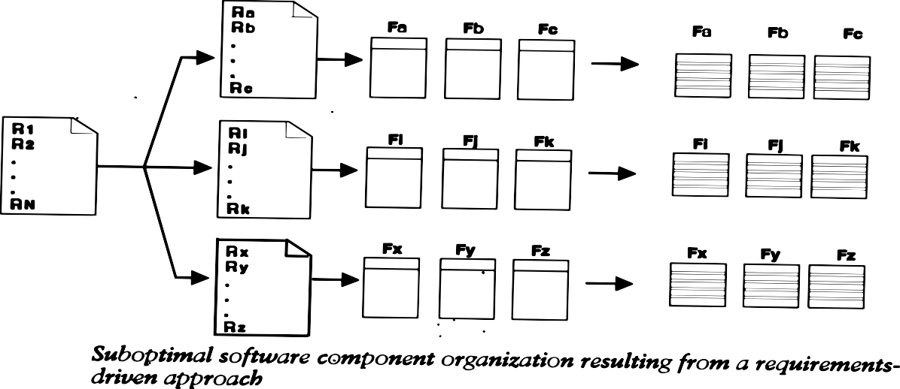

Adversarial Stakeholder Relationships:
The conventional process tended to result in adversarial stakeholder relationships, in large part because of the difficulties of requirements specification and the exchange of information solely through paper documents that captured engineering information in ad hoc formats.

The following sequence of events was typical for most contractual software efforts:
      - The contractor prepared a draft contract-deliverable document that captured an intermediate artifact and delivered it to the customer for approval.
      - The customer was expected to provide comments (typically within 15 to 30 days).
      - The contractor incorporated these comments and submitted (typically within 15 to 30 days) a final version for approval.
This one-shot review process encouraged high levels of sensitivity on the part of customers and contractors.

Focus on Documents and Review Meetings:
The conventional process focused on producing various documents that attempted to describe the software product, with insufficient focus on producing tangible increments of the products themselves. Contractors were driven to produce literally tons of paper to meet milestones and demonstrate progress to stakeholders, rather than spend their energy on tasks that would reduce risk and produce quality software. Typically, presenters and the audience reviewed the simple things that they understood rather than the complex and important issues. Most design reviews therefore resulted in low engineering value and high cost in terms of the effort and schedule involved in their preparation and conduct. They presented merely a facade of progress.
Table 1-2 summarizes the results of a typical design review.

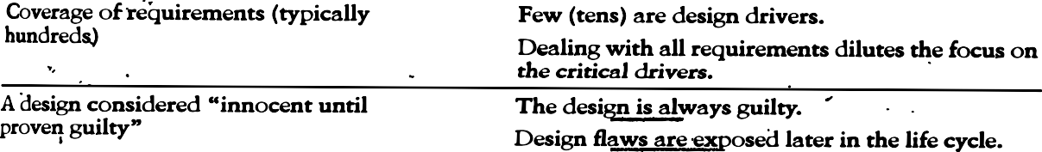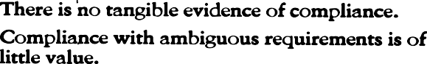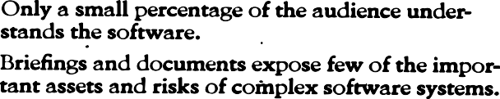

CONVENTIONAL SOFTWARE MANAGEMENT PERFORMANCE
Barry Boehm's "Industrial Software Metrics Top 10 List” is a good, objective characterization of the state of software development.
- Finding and fixing a software problem after delivery costs 100 times more than finding and fixing the problem in early design phases.
- You can compress software development schedules 25% of nominal, but no more.
- For every $1 you spend on development, you will spend $2 on maintenance.
- Software development and maintenance costs are primarily a function of the number of source lines of code.
- Variations among people account for the biggest differences in software productivity.
- The overall ratio of software to hardware costs is still growing. In 1955 it was 15:85; in 1985, 85:15.
- Only about 15% of software development effort is devoted to programming.
- Software systems and products typically cost 3 times as much per SLOC as individual software programs. Software-system products (i.e., system of systems) cost 9 times as much.
- Walkthroughs catch 60% of the errors
- 80% of the contribution comes from 20% of the contributors.

Evolution of Software Economics

SOFTWARE ECONOMICS
Most software cost models can be abstracted into a function of five basic parameters: size, process, personnel, environment, and required quality.
    - The size of the end product (in human-generated components), which is typically quantified in terms of the number of source instructions or the number of function points required to develop the required functionality
    - The process used to produce the end product, in particular the ability of the process to avoid non- value-adding activities (rework, bureaucratic delays, communications overhead)
    - The capabilities of software engineering personnel, and particularly their experience with the computer science issues and the applications domain issues of the project
    - The environment, which is made up of the tools and techniques available to support efficient software development and to automate the process
    - The required quality of the product, including its features, performance, reliability, and adaptability The relationships among these parameters and the estimated cost can be written as follows:

Effort = (Personnel) (Environment) (Quality) ( Size^{process})

One important aspect of software economics (as represented within today's software cost models) is that the relationship between effort and size exhibits a diseconomy of scale. The diseconomy of scale of software development is a result of the process exponent being greater than 1.0. Contrary to most manufacturing processes, the more software you build, the more expensive it is per unit item.
Figure 2-1 shows three generations of basic technology advancement in tools, components, and processes. The required levels of quality and personnel are assumed to be constant. The ordinate of the graph refers to software unit costs (pick your favorite: per SLOC, per function point, per component) realized by an organization.
The three generations of software development are defined as follows:
- Conventional: 1960s and 1970s, craftsmanship. Organizations used custom tools, custom processes, and virtually all custom components built in primitive languages. Project performance was highly predictable in that cost, schedule, and quality objectives were almost always underachieved.
- Transition: 1980s and 1990s, software engineering. Organiz:1tions used more-repeatable processes and off- the-shelf tools, and mostly (>70%) custom components built in higher level languages. Some of the components (<30%) were available as commercial products, including the operating system, database management system, networking, and graphical user interface.
- Modern practices: 2000 and later, software production. This book's philosophy is rooted in the use of managed and measured processes, integrated automation environments, and mostly (70%) off-the-shelf components. Perhaps as few as 30% of the components need to be custom built
Technologies for environment automation, size reduction, and process improvement are not independent of one another. In each new era, the key is complementary growth in all technologies. For example, the process advances could not be used successfully without new component technologies and increased tool automation.

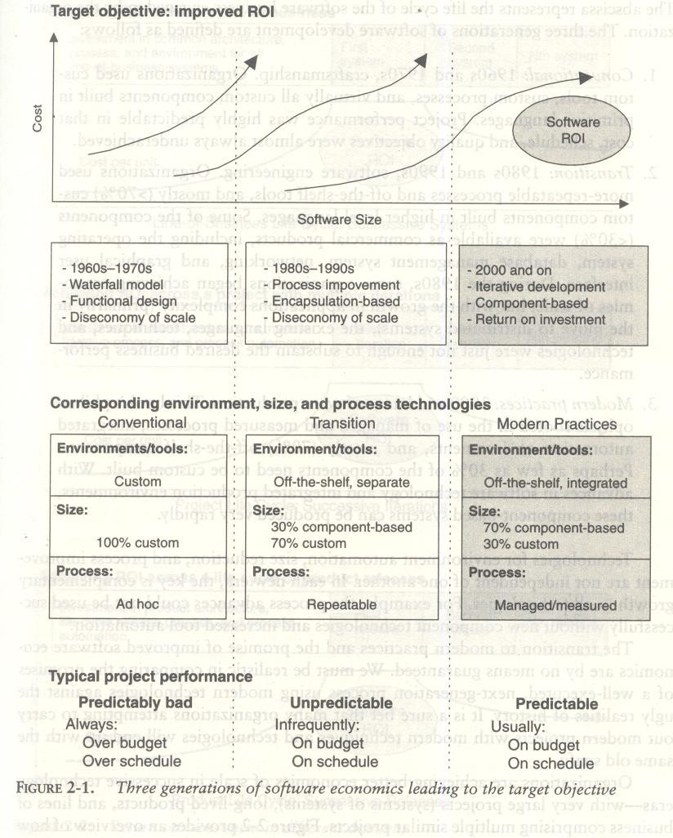

Organizations are achieving better economies of scale in successive technology eras-with very large projects (systems of systems), long-lived products, and lines of business comprising multiple similar projects. Figure 2-2 provides an overview of how a return on investment (ROI) profile can be achieved in subsequent efforts across life cycles of various domains.

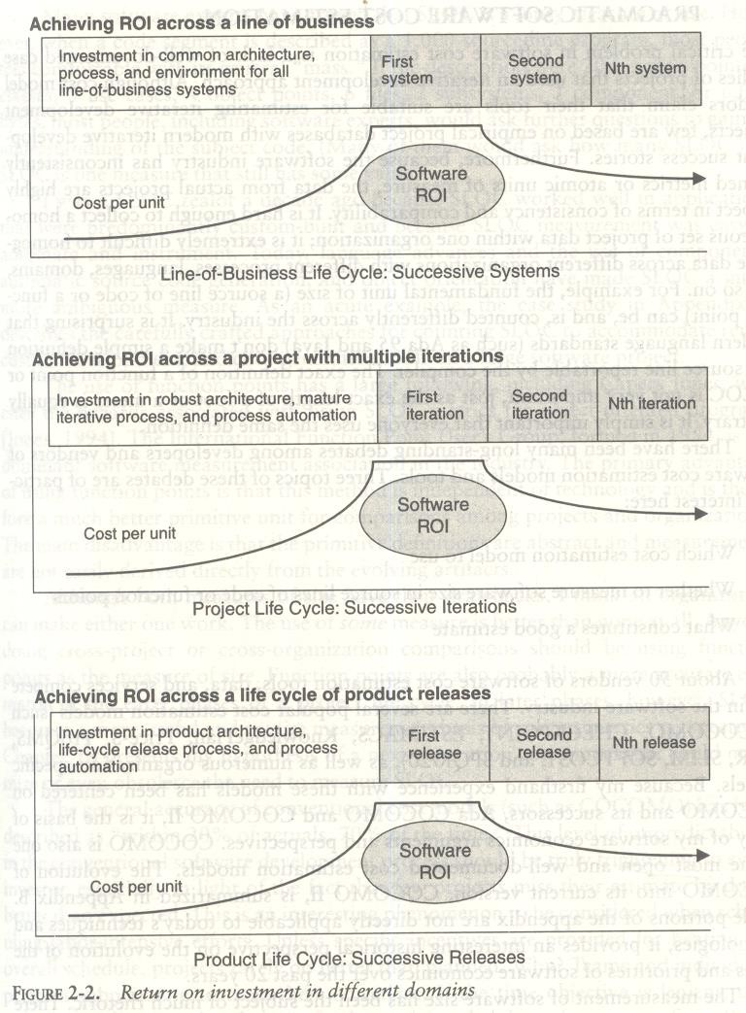

PRAGMATIC SOFTWARE COST ESTIMATION
One critical problem in software cost estimation is a lack of well-documented case studies of projects that used an iterative development approach. Software industry has inconsistently defined metrics or atomic units of measure, the data from actual projects are highly suspect in terms of consistency and comparability. It is hard enough to collect a homogeneous set of project data within one organization; it is extremely difficult to homog- enize data across different organizations with different processes, languages, domains, and so on.
There have been many debates among developers and vendors of software cost estimation models and tools. Three topics of these debates are of particular interest here:

    - Which cost estimation model to use?
    - Whether to measure software size in source lines of code or function points.
    - What constitutes a good estimate?
There are several popular cost estimation models (such as COCOMO, CHECKPOINT, ESTIMACS, Knowledge Plan, Price-S, ProQMS, SEER, SLIM, SOFTCOST, and SPQR/20), CO COMO is also one of the

most open and well-documented cost estimation models. The general accuracy of conventional cost models (such as COCOMO) has been described as "within 20% of actuals, 70% of the time."
Most real-world use of cost models is bottom-up (substantiating a target cost) rather than top-down (estimating the "should" cost). Figure 2-3 illustrates the predominant practice: The software project manager defines the target cost of the software, and then manipulates the parameters and sizing until the target cost can be justified. The rationale for the target cost maybe to win a proposal, to solicit customer funding, to attain internal corporate funding, or to achieve some other goal.
The process described in Figure 2-3 is not all bad. In fact, it is absolutely necessary to analyze the cost risks and understand the sensitivities and trade-offs objectively. It forces the software project manager to examine the risks associated with achieving the target costs and to discuss this information with other stakeholders.
A good software cost estimate has the following attributes:
- It is conceived and supported by the project manager, architecture team, development team, and test team accountable for performing the work.
- It is accepted by all stakeholders as ambitious but realizable.
- It is based on a well-defined software cost model with a credible basis.
- It is based on a database of relevant project experience that includes similar processes, similar technologies, similar environments, similar quality requirements, and similar people.
- It is defined in enough detail so that its key risk areas are understood and the probability of success is objectively assessed.
Extrapolating from a good estimate, an ideal estimate would be derived from a mature cost model with an experience base that reflects multiple similar projects done by the same team with the same mature processes and tools.
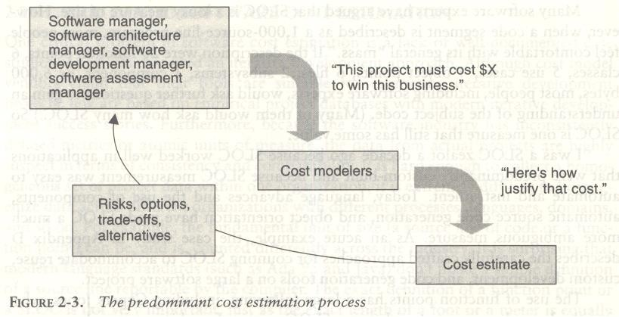

Improving Software Economics
Five basic parameters of the software cost model are
  - Reducing the size or complexity of what needs to be developed.
  - Improving the development process.
  - Using more-skilled personnel and better teams (not necessarily the same thing).
  - Using better environments (tools to automate the process).
  - Trading off or backing off on quality thresholds.

These parameters are given in priority order for most software domains. Table 3-1 lists some of the technology developments, process improvement efforts, and management approaches targeted at improving the economics of software development and integration.
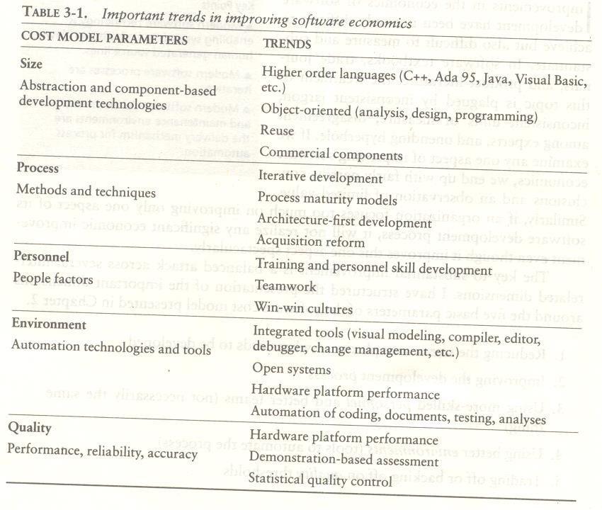

REDUCING SOFTWARE PRODUCT SIZE
The most significant way to improve affordability and return on investment (ROI) is usually to produce a product that achieves the design goals with the minimum amount of human-generated source material. Component-based development is introduced as the general term for reducing the "source" language size to achieve a software solution.
Reuse, object-oriented technology, automatic code production, and higher order programming languages are all focused on achieving a given system with fewer lines of human-specified source directives (statements).
size reduction is the primary motivation behind improvements in higher order languages (such as C++, Ada 95, Java, Visual Basic), automatic code generators (CASE tools, visual modeling tools, GUI builders), reuse of commercial components (operating systems, windowing environments, database management systems, middleware, networks), and object-oriented technologies (Unified Modeling Language, visual modeling tools, architecture frameworks).
The reduction is defined in terms of human-generated source material. In general, when size-reducing technologies are used, they reduce the number of human-generated source lines.

LANGUAGES
Universal function points (UFPs¹) are useful estimators for language-independent, early life-cycle estimates. The basic units of function points are external user inputs, external outputs, internal logical data groups, external data interfaces, and external inquiries. SLOC metrics are useful estimators for software after a candidate solution is formulated and an implementation language is known. Substantial data have been documented relating SLOC to function points. Some of these results are shown in Table 3-2.
Languages expressiveness of some of today’s popular languages
LANGUAGES | SLOC per UFP
Assembly | 320
C | 128
FORTAN77 | 105
COBOL85 | 91
Ada83 | 71
C++ | 56
Ada95 | 55
Java | 55
Visual Basic | 35
Table 3-2

OBJECT-ORIENTED METHODS AND VISUAL MODELING
Object-oriented technology is not germane to most of the software management topics discussed here, and books on object-oriented technology abound. Object-oriented programming languages appear to benefit both software productivity and software quality. The fundamental impact of object-oriented technology is in reducing the overall size of what needs to be developed.
People like drawing pictures to explain something to others or to themselves. When they do it for software system design, they call these pictures diagrams or diagrammatic models and the very notation for them a modeling language.
These are interesting examples of the interrelationships among the dimensions of improving software eco- nomics.

      - An object-oriented model of the problem and its solution encourages a common vocabulary between the end users of a system and its developers, thus creating a shared understanding of the problem being solved.
      - The use of continuous integration creates opportunities to recognize risk early and make incremental corrections without destabilizing the entire development effort.
      - An object-oriented architecture provides a clear separation of concerns among disparate elements of a system, creating firewalls that prevent a change in one part of the system from rending the fabric of the entire architecture.

1 Function point metrics provide a standardized method for measuring the various functions of a software application.
The basic units of function points are external user inputs, external outputs, internal logical data groups, external data interfaces, and external inquiries.

Booch also summarized five characteristics of a successful object-oriented project.
- A ruthless focus on the development of a system that provides a well understood collection of essential minimal characteristics.
- The existence of a culture that is centered on results, encourages communication, and yet is not afraid to fail.
- The effective use of object-oriented modeling.
- The existence of a strong architectural vision.
- The application of a well-managed iterative and incremental development life cycle.

REUSE
Reusing existing components and building reusable components have been natural software engineering activities since the earliest improvements in programming languages. With reuse in order to minimize development costs while achieving all the other required attributes of performance, feature set, and quality. Try to treat reuse as a mundane part of achieving a return on investment.
Most truly reusable components of value are transitioned to commercial products supported by organizations with the following characteristics:
- They have an economic motivation for continued support.
- They take ownership of improving product quality, adding new features, and transitioning to new technologies.
- They have a sufficiently broad customer base to be profitable.
The cost of developing a reusable component is not trivial. Figure 3-1 examines the economic trade-offs. The steep initial curve illustrates the economic obstacle to developing reusable components.
Reuse is an important discipline that has an impact on the efficiency of all workflows and the quality of most artifacts.
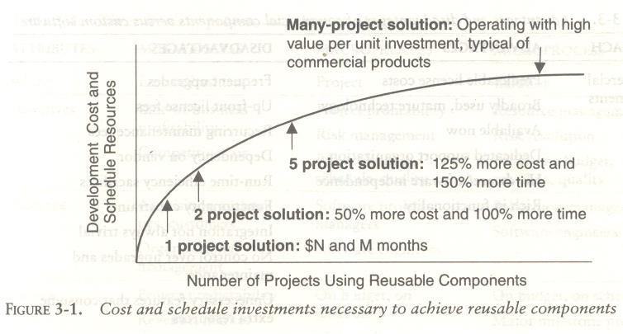

COMMERCIAL COMPONENTS
A common approach being pursued today in many domains is to maximize integration of commercial components and off-the-shelf products. While the use of commercial components is certainly desirable as a means of reducing custom development, it has not proven to be straightforward in practice. Table 3-3 identifies some of the advantages and disadvantages of using commercial components.
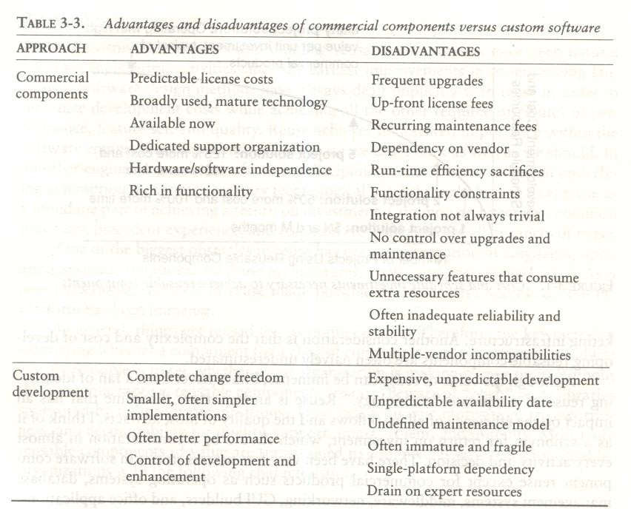

IMPROVING SOFTWARE PROCESSES
Process is an overloaded term. Three distinct process perspectives are.
- Metaprocess: an organization's policies, procedures, and practices for pursuing a software-intensive line of business. The focus of this process is on organizational economics, long-term strategies, and software ROI.
- Macroprocess: a project's policies, procedures, and practices for producing a complete software product within certain cost, schedule, and quality constraints. The focus of the macro process is on creating an adequate instance of the Meta process for a specific set of constraints.
- Microprocess: a project team's policies, procedures, and practices for achieving an artifact of the software process. The focus of the micro process is on achieving an intermediate product baseline with adequate quality and adequate functionality as economically and rapidly as practical.
Although these three levels of process overlap somewhat, they have different objectives, audiences, metrics, concerns, and time scales as shown in Table 3-4

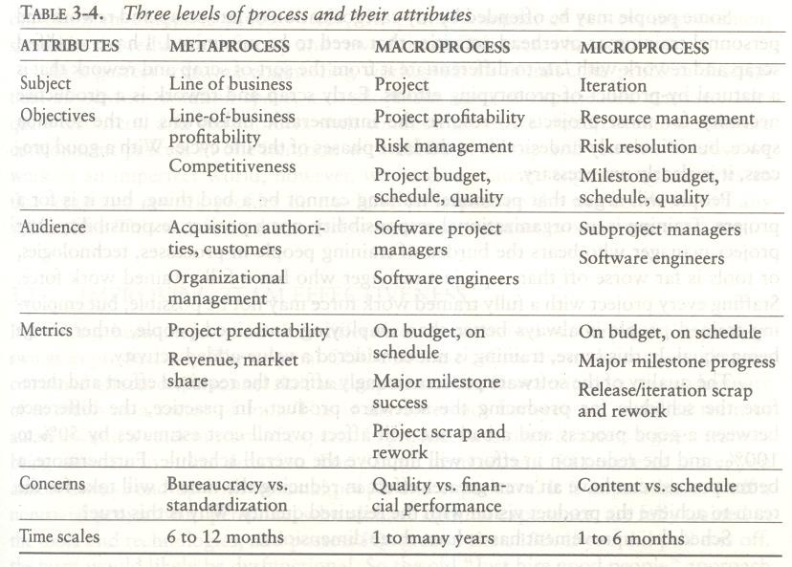
In a perfect software engineering world with an immaculate problem description, an obvious solution space, a development team of experienced geniuses, adequate resources, and stakeholders with common goals, we could execute a software development process in one iteration with almost no scrap and rework. Because we work in an imperfect world, however, we need to manage engineering activities so that scrap and rework profiles do not have an impact on the win conditions of any stakeholder. This should be the underlying premise for most process improvements.

IMPROVING TEAM EFFECTIVENESS
Teamwork is much more important than the sum of the individuals. With software teams, a project manager needs to configure a balance of solid talent with highly skilled people in the leverage positions. Some maxims of team management include the following:
- A well-managed project can succeed with a nominal engineering team.
- A mismanaged project will almost never succeed, even with an expert team of engineers.
- A well-architected system can be built by a nominal team of software builders.
- A poorly architected system will flounder even with an expert team of builders.

Boehm five staffing principles are
- The principle of top talent: Use better and fewer people
- The principle of job matching: Fit the tasks to the skills and motivation of the people available.
- The principle of career progression: An organization does best in the long run by helping its people to self-actualize.
- The principle of team balance: Select people who will complement and harmonize with one another
- The principle of phase-out: Keeping a misfit on the team doesn't benefit anyone

Software project managers need many leadership qualities in order to enhance team effectiveness. The following are some crucial attributes of successful software project managers that deserve much more attention:

- Hiring skills. Few decisions are as important as hiring decisions. Placing the right person in the right job seems obvious but is surprisingly hard to achieve.
- Customer-interface skill. Avoiding adversarial relationships among stakeholders is a prerequisite for success.
Decision-making skill. The jillion books written about management have failed to provide a clear definition of this attribute. We all know a good leader when we run into one, and decision-making skill seems obvious despite its intangible definition.
Team-building skill. Teamwork requires that a manager establish trust, motivate progress, exploit eccentric prima donnas, transition average people into top performers, eliminate misfits, and consolidate diverse opinions into a team direction.
Selling skill. Successful project managers must sell all stakeholders (including themselves) on decisions and priorities, sell candidates on job positions, sell changes to the status quo in the face of resistance, and sell achievements against objectives. In practice, selling requires continuous negotiation, compromise, and empathy

IMPROVING AUTOMATION THROUGH SOFTWARE ENVIRONMENTS
The tools and environment used in the software process generally have a linear effect on the productivity of the process. Planning tools, requirements management tools, visual modeling tools, compilers, editors, debuggers, quality assurance analysis tools, test tools, and user interfaces provide crucial automation support for evolving the software engineering artifacts. Above all, configuration management environments provide the foundation for executing and instrument the process. At first order, the isolated impact of tools and automation generally allows improvements of 20% to 40% in effort. However, tools and environments must be viewed as the primary delivery vehicle for process automation and improvement, so their impact can be much higher.
Automation of the design process provides payback in quality, the ability to estimate costs and schedules, and overall productivity using a smaller team.
Round-trip engineering describes the key capability of environments that support iterative development. As we have moved into maintaining different information repositories for the engineering artifacts, we need automation support to ensure efficient and error-free transition of data from one artifact to another. Forward engineering is the automation of one engineering artifact from another, more abstract representation. For example, compilers and linkers have provided automated transition of source code into executable code.
Reverse engineering is the generation or modification of a more abstract representation from an existing artifact (for example, creating a visual design model from a source code representation).
Economic improvements associated with tools and environments. It is common for tool vendors to make rela- tively accurate individual assessments of life-cycle activities to support claims about the potential economic impact of their tools. For example, it is easy to find statements such as the following from companies in a particular tool.
- Requirements analysis and evolution activities consume 40% of life-cycle costs.
- Software design activities have an impact on more than 50% of the resources.
- Coding and unit testing activities consume about 50% of software development effort and schedule.

- Test activities can consume as much as 50% of a project's resources.
- Configuration control and change management are critical activities that can consume as much as 25% of resources on a large-scale project.
- Documentation activities can consume more than 30% of project engineering resources.
- Project management, business administration, and progress assessment can consume as much as 30% of project budgets.

ACHIEVING REQUIRED QUALITY
Software best practices are derived from the development process and technologies. Table 3-5 summarizes some dimensions of quality improvement.
Key practices that improve overall software quality include the following:
- Focusing on driving requirements and critical use cases early in the life cycle, focusing on requirements completeness and traceability late in the life cycle, and focusing throughout the life cycle on a balance between requirements evolution, design evolution, and plan evolution
- Using metrics and indicators to measure the progress and quality of an architecture as it evolves from a high-level prototype into a fully compliant product
- Providing integrated life-cycle environments that support early and continuous configuration control, change management, rigorous design methods, document automation, and regression test automation
- Using visual modeling and higher level languages that support architectural control, abstraction, reliable programming, reuse, and self-documentation
- Early and continuous insight into performance issues through demonstration-based evaluations
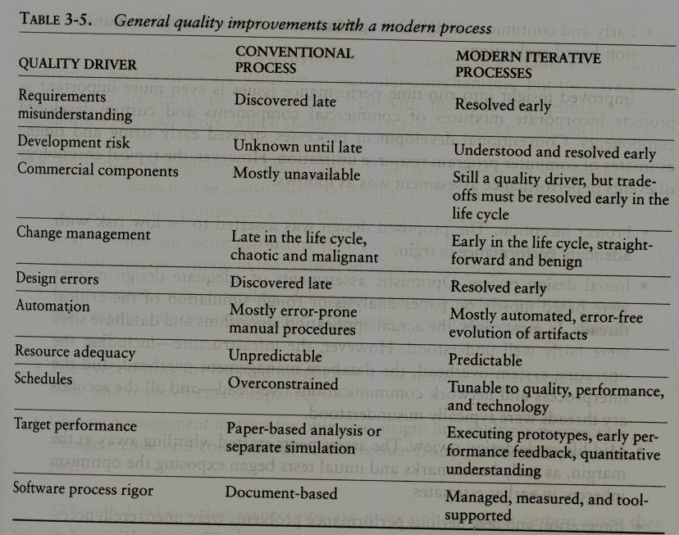

Conventional development processes stressed early sizing and timing estimates of computer program resource utilization. However, the typical chronology of events in performance assessment was as follows
- Project inception. The proposed design was asserted to be low risk with adequate performance margin.
- Initial design review. Optimistic assessments of adequate design margin were based mostly on paper analysis or rough simulation of the critical threads. In most cases, the actual application algorithms and database sizes were fairly well understood.
- Mid-life-cycle design review. The assessments started whittling away at the margin, as early benchmarks and initial tests began exposing the optimism inherent in earlier estimates.
- Integration and test. Serious performance problems were uncovered, necessitating fundamental changes in the architecture. The underlying infrastructure was usually the scapegoat, but the real culprit was immature use of the infrastructure, immature architectural solutions, or poorly understood early design trade-offs.

PEER INSPECTIONS: A PRAGMATIC VIEW
Peer inspections are frequently over hyped as the key aspect of a quality system. In my experience, peer reviews are valuable as secondary mechanisms, but they are rarely significant contributors to quality compared with the following primary quality mechanisms and indicators, which should be emphasized in the management process:
- Transitioning engineering information from one artifact set to another, thereby assessing the consistency, feasibility, understandability, and technology constraints inherent in the engineering artifacts
- Major milestone demonstrations that force the artifacts to be assessed against tangible criteria in the context of relevant use cases
- Environment tools (compilers, debuggers, analyzers, automated test suites) that ensure representation rigor, consistency, completeness, and change control
- Life-cycle testing for detailed insight into critical trade-offs, acceptance criteria, and requirements compliance
- Change management metrics for objective insight into multiple-perspective change trends and convergence or divergence from quality and progress goals
Inspections are also a good vehicle for holding authors accountable for quality products. All authors of software and documentation should have their products scrutinized as a natural by-product of the process. Therefore, the coverage of inspections should be across all authors rather than across all components.

UNIT – II

Conventional and Modern Software Management: The principles of conventional software Engineering, principles of modern software management, transitioning to an iterative process.
Life cycle phases: Engineering and Production stages, Inception, Elaboration, Construction, Transition Phases.

CONVENTIONAL AND MODERN SOFTWARE MANAGEMENT
THE PRINCIPLES OF CONVENTIONAL SOFTWARE ENGINEERING

- Make quality Quality must be quantified and mechanisms put into place to motivate its achievement
- High-quality software is possible. Techniques that have been demonstrated to increase quality include involving the customer, prototyping, simplifying design, conducting inspections, and hiring the best people
- Give products to customers early. No matter how hard you try to learn users' needs during the requirements phase, the most effective way to determine real needs is to give users a product and let them play with it 4.Determine the problem before writing the requirements. When faced with what they believe is a problem, most engineers rush to offer a solution. Before you try to solve a problem, be sure to explore all the alternatives and don't be blinded by the obvious solution
- Evaluate design alternatives. After the requirements are agreed upon, you must examine a variety of architectures and algorithms. You certainly do not want to use” architecture" simply because it was used in the requirements specification.
- Use an appropriate process model. Each project must select a process that makes ·the most sense for that project on the basis of corporate culture, willingness to take risks, application area, volatility of requirements, and the extent to which requirements are well understood.
- Use different languages for different phases. Our industry's eternal thirst for simple solutions to complex problems has driven many to declare that the best development method is one that uses the same notation through- out the life cycle.
- Minimize intellectual distance. To minimize intellectual distance, the software's structure should be as close as possible to the real-world structure
- Put techniques before tools. An undisciplined software engineer with a tool becomes a dangerous, undisciplined software engineer
- Get it right before you make it faster. It is far easier to make a working program run faster than it is to make a fast program work. Don't worry about optimization during initial coding
- Inspect code. Inspecting the detailed design and code is a much better way to find errors than testing
- Good management is more important than good technology. Good management motivates people to do their best, but there are no universal "right" styles of management.

- People are the key to success. Highly skilled people with appropriate experience, talent, and training are key. 14.Follow with care. Just because everybody is doing something does not make it right for you. It may be right, but you must carefully assess its applicability to your environment.
- Take responsibility. When a bridge collapses we ask, "What did the engineers do wrong?" Even when software fails, we rarely ask this. The fact is that in any engineering discipline, the best methods can be used to produce awful designs, and the most antiquated methods to produce elegant designs.
- Understand the customer's priorities. It is possible the customer would tolerate 90% of the functionality delivered late if they could have 10% of it on time.
- The more they see, the more they need. The more functionality (or performance) you provide a user, the more functionality (or performance) the user wants.
- Plan to throw one away. One of the most important critical success factors is whether or not a product is entirely new. Such brand-new applications, architectures, interfaces, or algorithms rarely work the first time.
- Design for change. The architectures, components, and specification techniques you use must accommodate change.
- Design without documentation is not design. I have often heard software engineers say, "I have finished the design. All that is left is the documentation. "
- Use tools, but be realistic. Software tools make their users more efficient.
- Avoid tricks. Many programmers love to create programs with tricks constructs that perform a function correctly, but in an obscure way. Show the world how smart you are by avoiding tricky code
- Encapsulate. Information-hiding is a simple, proven concept that results in software that is easier to test and much easier to maintain.
- Use coupling and cohesion. Coupling and cohesion are the best ways to measure software's inherent maintainability and adaptability
- Use the McCabe complexity measure. Although there are many metrics available to report the inherent complexity of software, none is as intuitive and easy to use as Tom McCabe's
- Don't test your own software. Software developers should never be the primary testers of their own software.
- Analyze causes for errors. It is far more cost-effective to reduce the effect of an error by preventing it than it is to find and fix it. One way to do this is to analyze the causes of errors as they are detected
- Realize that software's entropy increases. Any software system that undergoes continuous change will grow in complexity and will become more and more disorganized
- People and time are not interchangeable. Measuring a project solely by person-months makes little sense 30.Expect excellence. Your employees will do much better if you have high expectations for them.

THE PRINCIPLES OF MODERN SOFTWARE MANAGEMENT

Top 10 principles of modern software management are. (The first five, which are the main themes of my definition of an iterative process, are summarized in Figure 4-1.)

    - Base the process on an architecture-first approach. This requires that a demonstrable balance be achieved among the driving requirements, the architecturally significant design decisions, and the life- cycle plans before the resources are committed for full-scale development.
    - Establish an iterative life-cycle process that confronts risk early. With today's sophisticated software systems, it is not possible to define the entire problem, design the entire solution, build the software, and then test the end product in sequence. Instead, an iterative process that refines the problem understanding, an effective solution, and an effective plan over several iterations encourages a balanced treatment of all stakeholder objectives. Major risks must be addressed early to increase predictability and avoid expensive downstream scrap and rework.
    - Transition design methods to emphasize component-based development. Moving from a line-of- code mentality to a component-based mentality is necessary to reduce the amount of human-generated source code and custom development.
    - Establish a change management environment. The dynamics of iterative development,
including concurrent workflows by different teams working on shared artifacts, necessitates objectively controlled baselines.
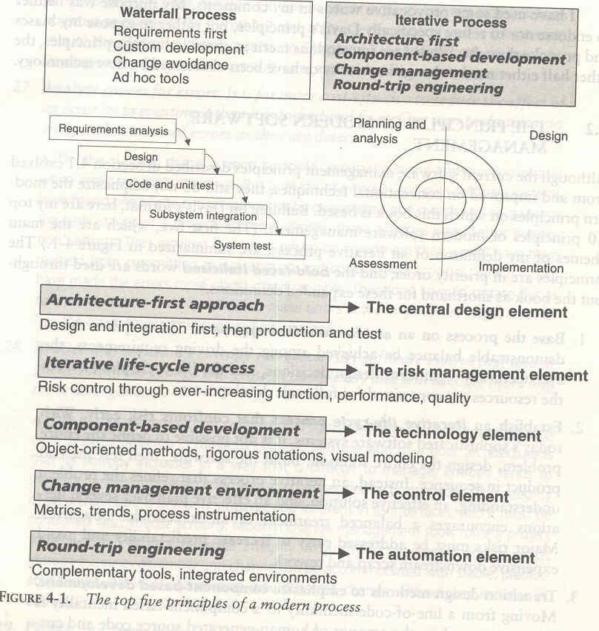

    - Enhance change freedom through tools that support round-trip engineering. Round-trip engineering is the environment support necessary to automate and synchronize
engineering information in different formats(such as requirements specifications, design models, source code, executable code, test cases).
    - Capture design artifacts in rigorous, model-based notation. A model based approach (such as UML) supports the evolution of semantically rich graphical and textual design notations.
    - Instrument the process for objective quality control and progress assessment. Life-cycle assessment of the progress and the quality of all intermediate products must be integrated into the process.

Use a demonstration-based approach to assess intermediate artifacts.
    - Plan intermediate releases in groups of usage scenarios with evolving levels of detail. It is essential that the software management process drive toward early and continuous demonstrations within the operational context of the system, namely its use cases.
    - Establish a configurable process that is economically scalable. No single process is suitable for all software developments.

Table 4-1 maps top 10 risks of the conventional process to the key attributes and principles of a modern process
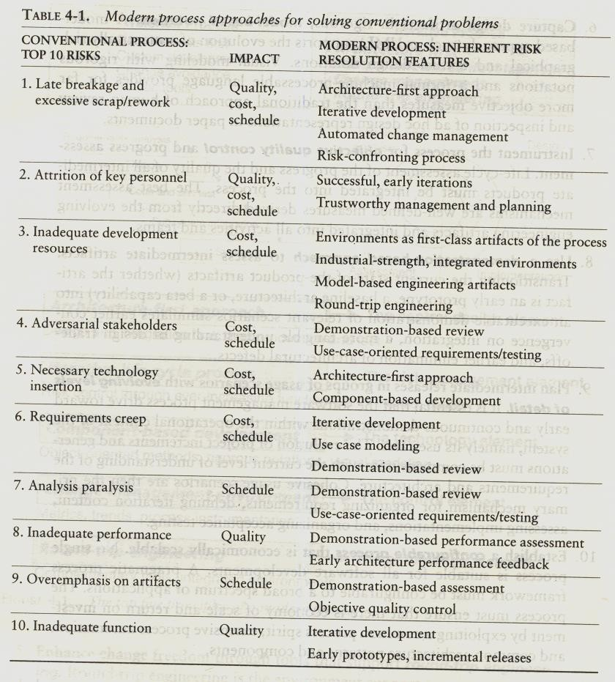

TRANSITIONING TO AN ITERATIVE PROCESS
Modern software development processes have moved away from the conventional waterfall model, in which each stage of the development process is dependent on completion of the previous stage.
The economic benefits inherent in transitioning from the conventional waterfall model to an iterative development process are significant but difficult to quantify. As one benchmark of the expected economic impact of process improvement, consider the process exponent parameters of the COCOMO II model. (Appendix B provides more detail on the COCOMO model) This exponent can range from 1.01 (virtually no diseconomy of scale) to 1.26 (significant diseconomy of scale). The parameters that govern the value of the process exponent are application precedentedness, process flexibility, architecture risk resolution, team cohesion, and software process maturity.
The following paragraphs map the process exponent parameters of CO COMO II to my top 10 principles of a modern process.
- Application precedentedness. Domain experience is a critical factor in understanding how to plan and execute a software development project. For unprecedented systems, one of the key goals is to confront risks and establish early precedents, even if they are incomplete or experimental. This is one of the primary reasons that the software industry has moved to an iterative life-cycle process. Early iterations in the life cycle establish precedents from which the product, the process, and the plans can be elaborated in evolving levels of detail.
- Process flexibility. Development of modern software is characterized by such a broad solution space and so many interrelated concerns that there is a paramount need for continuous incorporation of changes. These changes may be inherent in the problem understanding, the solution space, or the plans. Project artifacts must be supported by efficient change management commensurate with project needs. A configurable process that allows a common framework to be adapted across a range of projects is necessary to achieve a software return on investment.
- Architecture risk resolution. Architecture-first development is a crucial theme underlying a successful iterative development process. A project team develops and stabilizes architecture before developing all the components that make up the entire suite of applications components. An architecture-first and component-based development approach forces the infrastructure, common mechanisms, and control mechanisms to be elaborated early in the life cycle and drives all component make/buy decisions into the architecture process.
- Team cohesion. Successful teams are cohesive, and cohesive teams are successful. Successful teams and cohesive teams share common objectives and priorities. Advances in technology (such as programming languages, UML, and visual modeling) have enabled more rigorous and understandable notations for communicating software engineering information, particularly in the requirements and design artifacts that previously were ad hoc and based completely on paper exchange. These model-based formats have also enabled the round-trip engineering support needed to establish change freedom sufficient for evolving design representations.
- Software process maturity. The Software Engineering Institute's Capability Maturity Model (CMM) is a well-accepted benchmark for software process assessment. One of key themes is that truly mature processes are enabled through an integrated environment that provides the appropriate level of automation to instrument the process for objective quality control.

Important questions

1. | Explain briefly Waterfall model. Also explain Conventional s/w management performance?
2. | Define Software Economics. Also explain Pragmatic s/w cost estimation?
3. | Explain Important trends in improving Software economics?
4. | Explain five staffing principal offered by Boehm. Also explain Peer Inspections?
5.. | Explain principles of conventional software engineering?
6. | Explain briefly principles of modern software management

  - Life cycle phases
Characteristic of a successful software development process is the well-defined separation between "research and development" activities and "production" activities. Most unsuccessful projects exhibit one of the following characteristics:
    - An overemphasis on research and development
    - An overemphasis on production.
Successful modern projects-and even successful projects developed under the conventional process-tend to have a very well-defined project milestone when there is a noticeable transition from a research attitude to a production attitude. Earlier phases focus on achieving functionality. Later phases revolve around achieving a product that can be shipped to a customer, with explicit attention to robustness, performance, and finish.
A modern software development process must be defined to support the following:
    - Evolution of the plans, requirements, and architecture, together with well defined synchronization points
    - Risk management and objective measures of progress and quality
    - Evolution of system capabilities through demonstrations of increasing functionality

ENGINEERING AND PRODUCTION STAGES

To achieve economies of scale and higher returns on investment, we must move toward a software manufacturing process driven by technological improvements in process automation and component-based development. Two stages of the life cycle are:
    - The engineering stage, driven by less predictable but smaller teams doing design and synthesis activities
    - The production stage, driven by more predictable but larger teams doing construction, test, and deployment activities

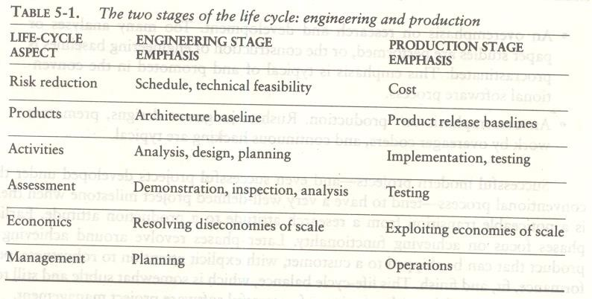

The transition between engineering and production is a crucial event for the various stakeholders. The production plan has been agreed upon, and there is a good enough understanding of the problem and the solution that all stakeholders can make a firm commitment to go ahead with production.
Engineering stage is decomposed into two distinct phases, inception and elaboration, and the production stage into construction and transition. These four phases of the life-cycle process are loosely mapped to the conceptual framework of the spiral model as shown in Figure 5-1
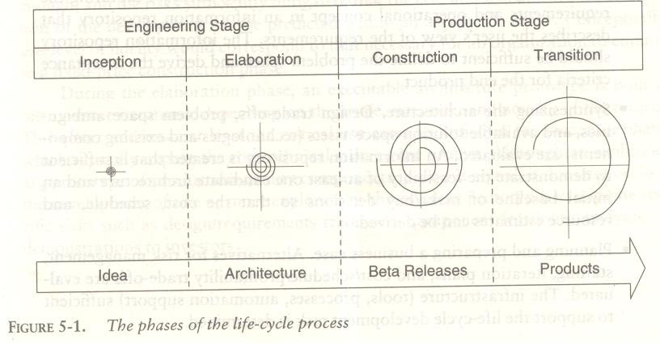

INCEPTION PHASE
The overriding goal of the inception phase is to achieve concurrence among stakeholders on the life-cycle objectives for the project.
PRIMARY OBJECTIVES
- Establishing the project's software scope and boundary conditions, including an operational concept, acceptance criteria, and a clear understanding of what is and is not intended to be in the product
- Discriminating the critical use cases of the system and the primary scenarios of operation that will drive the major design trade-offs
- Demonstrating at least one candidate architecture against some of the primary scenanos
- Estimating the cost and schedule for the entire project (including detailed estimates for the elaboration phase)
- Estimating potential risks (sources of unpredictability)

ESSENTIAL ACTMTIES
- Formulating the scope of the project. The information repository should be sufficient to define the problem space and derive the acceptance criteria for the end product.
- Synthesizing the architecture. An information repository is created that is sufficient to demonstrate the feasibility of at least one candidate architecture and an, initial baseline of make/buy decisions so that the cost, schedule, and resource estimates can be derived.
- Planning and preparing a business case. Alternatives for risk management, staffing, iteration plans, and cost/schedule/profitability trade-offs are evaluated.
PRIMARY EVALUATION CRITERIA
- Do all stakeholders concur on the scope definition and cost and schedule estimates?
- Are requirements understood, as evidenced by the fidelity of the critical use cases?
- Are the cost and schedule estimates, priorities, risks, and development processes credible?
- Do the depth and breadth of an architecture prototype demonstrate the preceding criteria? (The primary value of prototyping candidate architecture is to provide a vehicle for understanding the scope and assessing the credibility of the development group in solving the particular technical problem.)
- Are actual resource expenditures versus planned expenditures acceptable

ELABORATION PHASE

At the end of this phase, the "engineering" is considered complete. The elaboration phase activities must ensure that the architecture, requirements, and plans are stable enough, and the risks sufficiently mitigated, that the cost and schedule for the completion of the development can be predicted within an acceptable range. During the elaboration phase, an executable architecture prototype is built in one or more iterations, depending on the scope, size, & risk.
PRIMARY OBJECTIVES
    - Baselining the architecture as rapidly as practical (establishing a configuration-managed snapshot in which all changes are rationalized, tracked, and maintained)
    - Baselining the vision
    - Baselining a high-fidelity plan for the construction phase
    - Demonstrating that the baseline architecture will support the vision at a reasonable cost in a reasonable time

ESSENTIAL ACTIVITIES
    - Elaborating the vision.
    - Elaborating the process and infrastructure.
    - Elaborating the architecture and selecting components.

PRIMARY EVALUATION CRITERIA
    - Is the vision stable?
    - Is the architecture stable?
    - Does the executable demonstration show that the major risk elements have been addressed and credibly resolved?
    - Is the construction phase plan of sufficient fidelity, and is it backed up with a credible basis of estimate?
    - Do all stakeholders agree that the current vision can be met if the current plan is executed to develop the

complete system in the context of the current architecture?
    - Are actual resource expenditures versus planned expenditures acceptable?

CONSTRUCTION PHASE
During the construction phase, all remaining components and application features are integrated into the application, and all features are thoroughly tested. Newly developed software is integrated where required. The construction phase represents a production process, in which emphasis is placed on managing resources and controlling operations to optimize costs, schedules, and quality.

PRIMARY OBJECTIVES
    - Minimizing development costs by optimizing resources and avoiding unnecessary scrap and rework
    - Achieving adequate quality as rapidly as practical
    - Achieving useful versions (alpha, beta, and other test releases) as rapidly as practical

ESSENTIAL ACTIVITIES
    - Resource management, control, and process optimization
    - Complete component development and testing against evaluation criteria
    - Assessment of product releases against acceptance criteria of the vision
PRIMARY EVALUATION CRITERIA
    - Is this product baseline mature enough to be deployed in the user community? (Existing defects are not obstacles to achieving the purpose of the next release.)
    - Is this product baseline stable enough to be deployed in the user community? (Pending changes are not obstacles to achieving the purpose of the next release.)
    - Are the stakeholders ready for transition to the user community?
    - Are actual resource expenditures versus planned expenditures acceptable?

TRANSITION PHASE
The transition phase is entered when a baseline is mature enough to be deployed in the end-user domain. This typically requires that a usable subset of the system has been achieved with acceptable quality levels and user documentation so that transition to the user will provide positive results. This phase could include any of the following activities:

- Beta testing to validate the new system against user expectations
- Beta testing and parallel operation relative to a legacy system it is replacing
- Conversion of operational databases
- Training of users and maintainers
The transition phase concludes when the deployment baseline has achieved the complete vision.

PRIMARY OBJECTIVES
- Achieving user self-supportability
- Achieving stakeholder concurrence that deployment baselines are complete and consistent with the evaluation criteria of the vision
- Achieving final product baselines as rapidly and cost-effectively as practical

ESSENTIAL ACTIVITIES
- Synchronization and integration of concurrent construction increments into consistent deployment baselines
- Deployment-specific engineering (cutover, commercial packaging and production, sales rollout kit development, field personnel training)
- Assessment of deployment baselines against the complete vision and acceptance criteria in the requirements set
EVALUATION CRITERIA
- Is the user satisfied?
- Are actual resource expenditures versus planned expenditures acceptable?

UNIT - III
Artifacts of the process: The artifact sets, Management artifacts, Engineering artifacts, programmatic artifacts.
Model based software architectures: A Management perspective and technical perspective.

Artifacts of the process

THE ARTIFACT SETS
To make the development of a complete software system manageable, distinct collections of information are organized into artifact sets. Artifact represents cohesive information that typically is developed and reviewed as a single entity.
Life-cycle software artifacts are organized into five distinct sets that are roughly partitioned by the underlying language of the set: management (ad hoc textual formats), requirements (organized text and models of the problem space), design (models of the solution space), implementation (human-readable programming language and associated source files), and deployment (machine-process able languages and associated files). The artifact sets are shown in Figure 6-1.
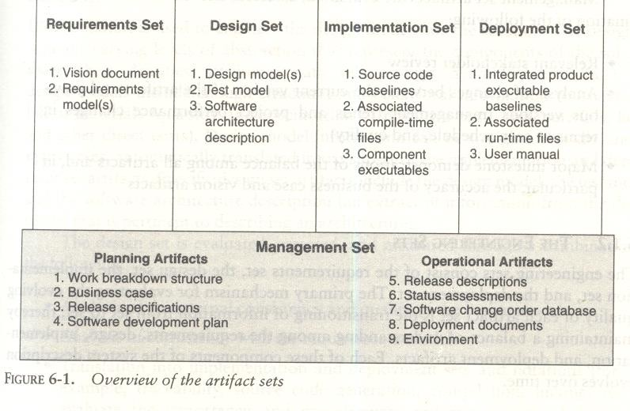

THE MANAGEMENT SET
The management set captures the artifacts associated with process planning and execution. These artifacts use ad hoc notations, including text, graphics, or whatever representation is required to capture the "contracts" among project personnel (project management, architects, developers, testers, marketers, administrators), among stakeholders (funding authority, user, software project manager, organization manager, regulatory agency), and between project personnel and stakeholders. Specific artifacts included in this set are the work breakdown structure (activity breakdown and financial tracking mechanism), the business case (cost, schedule, profit expectations), the release specifications (scope, plan, objectives for release baselines), the software development plan (project process instance), the release descriptions (results of release baselines), the status assessments (periodic snapshots of project progress), the software change orders (descriptions of discrete baseline changes), the deployment documents (cutover plan, training course, sales rollout kit), and the environment (hardware and software tools, process automation, & documentation).

Management set artifacts are evaluated, assessed, and measured through a combination of the following:
- Relevant stakeholder review
- Analysis of changes between the current version of the artifact and previous versions
- Major milestone demonstrations of the balance among all artifacts and, in particular, the accuracy of the business case and vision artifacts

THE ENGINEERING SETS
The engineering sets consist of the requirements set, the design set, the implementation set, and the deployment set.

Requirements Set
Requirements artifacts are evaluated, assessed, and measured through a combination of the following:
      - Analysis of consistency with the release specifications of the management set
      - Analysis of consistency between the vision and the requirements models
      - Mapping against the design, implementation, and deployment sets to evaluate the consistency and completeness and the semantic balance between information in the different sets
      - Analysis of changes between the current version of requirements artifacts and previous versions (scrap, rework, and defect elimination trends)
      - Subjective review of other dimensions of quality

Design Set
UML notation is used to engineer the design models for the solution. The design set contains varying levels of abstraction that represent the components of the solution space (their identities, attributes, static relationships, dynamic interactions). The design set is evaluated, assessed, and measured through a combination of the following:
      - Analysis of the internal consistency and quality of the design model
      - Analysis of consistency with the requirements models
      - Translation into implementation and deployment sets and notations (for example, traceability, source code generation, compilation, linking) to evaluate the consistency and completeness and the semantic balance between information in the sets
      - Analysis of changes between the current version of the design model and previous versions (scrap, rework, and defect elimination trends)
      - Subjective review of other dimensions of quality

Implementation set
The implementation set includes source code (programming language notations) that represents the tangible implementations of components (their form, interface, and dependency relationships)
Implementation sets are human-readable formats that are evaluated, assessed, and measured through a
combination of the following:
      - Analysis of consistency with the design models
      - Translation into deployment set notations (for example, compilation and linking) to evaluate the consistency and completeness among artifact sets
      - Assessment of component source or executable files against relevant evaluation criteria through inspection, analysis, demonstration, or testing
      - Execution of stand-alone component test cases that automatically compare expected results with actual results
      - Analysis of changes between the current version of the implementation set and previous versions (scrap, rework, and defect elimination trends)
      - Subjective review of other dimensions of quality

Deployment Set
The deployment set includes user deliverables and machine language notations, executable software, and the
build scripts, installation scripts, and executable target specific data necessary to use the product in its target environment.
Deployment sets are evaluated, assessed, and measured through a combination of the following:
      - Testing against the usage scenarios and quality attributes defined in the requirements set to evaluate the consistency and completeness and the~ semantic balance between information in the two sets
      - Testing the partitioning, replication, and allocation strategies in mapping components of the implementation set to physical resources of the deployment system (platform type, number, network topology)
      - Testing against the defined usage scenarios in the user manual such as installation, user-oriented dynamic reconfiguration, mainstream usage, and anomaly management
      - Analysis of changes between the current version of the deployment set and previous versions (defect elimination trends, performance changes)
      - Subjective review of other dimensions of quality
Each artifact set is the predominant development focus of one phase of the life cycle; the other sets take on check and balance roles. As illustrated in Figure 6-2, each phase has a predominant focus: Requirements are the focus of the inception phase; design, the elaboration phase; implementation, the construction phase; and deploy- ment, the transition phase. The management artifacts also evolve, but at a fairly constant level across the life cycle.
Most of today's software development tools map closely to one of the five artifact sets.
- Management: scheduling, workflow, defect tracking, change management, documentation, spreadsheet, resource management, and presentation tools
- Requirements: requirements management tools
- Design: visual modeling tools
- Implementation: compiler/debugger tools, code analysis tools, test coverage analysis tools, and test management tools
- Deployment: test coverage and test automation tools, network management tools, commercial components (operating systems, GUIs, RDBMS, networks, middleware), and installation tools.
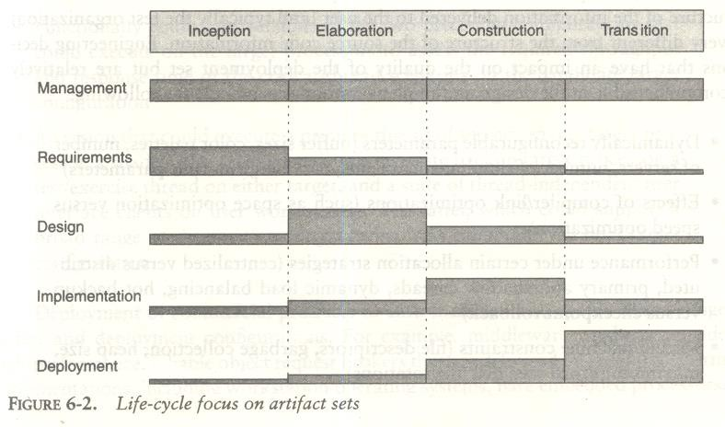

Implementation Set versus Deployment Set
The separation of the implementation set (source code) from the deployment set (executable code) is important because there are very different concerns with each set. The structure of the information delivered to the user (and typically the test organization) is very different from the structure of the source code information. Engineering decisions that have an impact on the quality of the deployment set but are relatively incomprehensible in the design and implementation sets include the following:
      - Dynamically reconfigurable parameters (buffer sizes, color palettes, number of servers, number of simultaneous clients, data files, run-time parameters)
      - Effects of compiler/link optimizations (such as space optimization versus speed optimization)
      - Performance under certain allocation strategies (centralized versus distributed, primary and shadow threads, dynamic load balancing, hot backup versus checkpoint/rollback)
      - Virtual machine constraints (file descriptors, garbage collection, heap size, maximum record size, disk file rotations)
      - Process-level concurrency issues (deadlock and race conditions)
      - Platform-specific differences in performance or behavior

ARTIFACT EVOLUTION OVER THE LIFE CYCLE
Each state of development represents a certain amount of precision in the final system description. Early in the life cycle, precision is low and the representation is generally high. Eventually, the precision of representation is high and everything is specified in full detail. Each phase of development focuses on a particular artifact set. At the end of each phase, the overall system state will have progressed on all sets, as illustrated in Figure 6-3.
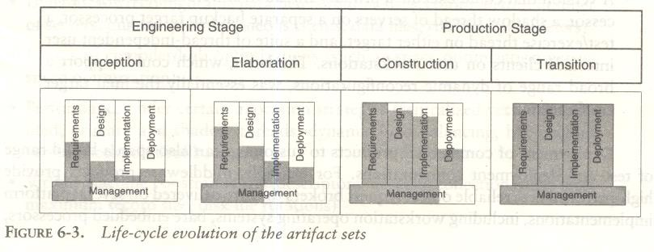
The inception phase focuses mainly on critical requirements usually with a secondary focus on an initial deployment view. During the elaboration phase, there is much greater depth in requirements, much more breadth in the design set, and further work on implementation and deployment issues. The main focus of the construction phase is design and implementation. The main focus of the transition phase is on achieving consistency and completeness of the deployment set in the context of the other sets.

TEST ARTIFACTS
      - The test artifacts must be developed concurrently with the product from inception through deployment. Thus, testing is a full-life-cycle activity, not a late life-cycle activity.
      - The test artifacts are communicated, engineered, and developed within the same artifact sets as the developed product.
      - The test artifacts are implemented in programmable and repeatable formats (as software programs).
      - The test artifacts are documented in the same way that the product is documented.
      - Developers of the test artifacts use the same tools, techniques, and training as the software engineers developing the product.
Test artifact subsets are highly project-specific, the following example clarifies the relationship between test artifacts and the other artifact sets. Consider a project to perform seismic data processing for the purpose of oil exploration. This system has three fundamental subsystems: (1) a sensor subsystem that captures raw seismic data in real time and delivers these data to (2) a technical operations subsystem that converts raw data into an organized database and manages queries to this database from (3) a display subsystem that allows workstation operators to examine seismic data in human-readable form. Such a system would result in the following test artifacts:

      - Management set. The release specifications and release descriptions capture the objectives, evaluation criteria, and results of an intermediate milestone. These artifacts are the test plans and test results negotiated among internal project teams. The software change orders capture test results (defects, testability changes, requirements ambiguities, enhancements) and the closure criteria associated with making a discrete change to a baseline.
      - Requirements set. The system-level use cases capture the operational concept for the system and the acceptance test case descriptions, including the expected behavior of the system and its quality attributes. The entire requirement set is a test artifact because it is the basis of all assessment activities across the life cycle.
      - Design set. A test model for nondeliverable components needed to test the product baselines is captured in the design set. These components include such design set artifacts as a seismic event simulation for creating realistic sensor data; a "virtual operator" that can support unattended, after- hours test cases; specific instrumentation suites for early demonstration of resource usage; transaction rates or response times; and use case test drivers and component stand-alone test drivers.
      - Implementation set. Self-documenting source code representations for test components and test drivers provide the equivalent of test procedures and test scripts. These source files may also include human-readable data files representing certain statically defined data sets that are explicit test source files. Output files from test drivers provide the equivalent of test reports.
      - Deployment set. Executable versions of test components, test drivers, and data files are provided.

MANAGEMENT ARTIFACTS
The management set includes several artifacts that capture intermediate results and ancillary information necessary to document the product/process legacy, maintain the product, improve the product, and improve the process.

Business Case
The business case artifact provides all the information necessary to determine whether the project is worth investing in. It details the expected revenue, expected cost, technical and management plans, and backup data necessary to demonstrate the risks and realism of the plans. The main purpose is to transform the vision into economic terms so that an organization can make an accurate ROI assessment. The financial forecasts are evolutionary, updated with more accurate forecasts as the life cycle progresses. Figure 6-4

provides a default outline for a business case.

Software Development Plan
The software development plan (SDP) elaborates the process framework into a fully detailed plan. Two indications of a useful SDP are periodic updating (it is not stagnant shelfware) and understanding and acceptance by managers and practitioners alike. Figure 6-5 provides a default outline for a software development plan.
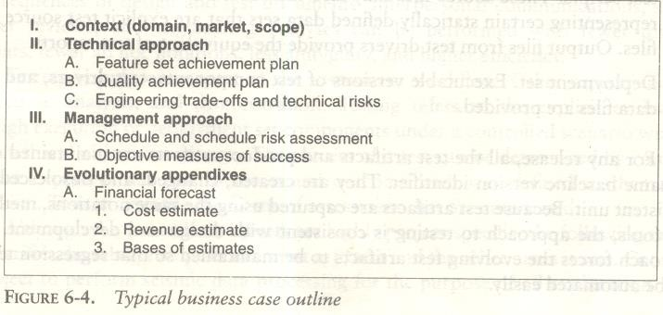
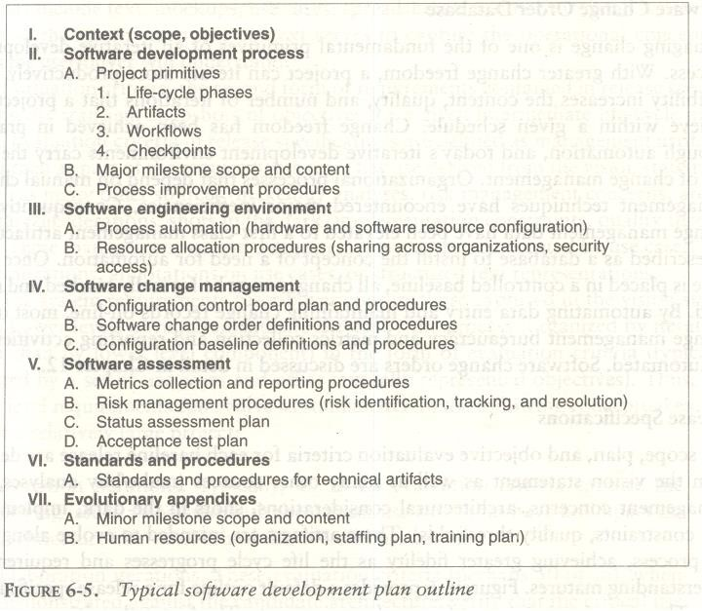

Work Breakdown Structure
Work breakdown structure (WBS) is the vehicle for budgeting and collecting costs. To monitor and control a project's financial performance, the software project man1ger must have insight into project costs and how they are expended. The structure of cost accountability is a serious project planning constraint.

Software Change Order Database
Managing change is one of the fundamental primitives of an iterative development process. With greater change freedom, a project can iterate more productively. This flexibility increases the content, quality, and number of iterations that a project can achieve within a given schedule. Change freedom has been achieved in practice through automation, and today's iterative development environments carry the burden of change management. Organizational processes that depend on manual change management techniques have encountered major inefficiencies.

Release Specifications
The scope, plan, and objective evaluation criteria for each baseline release are derived from the vision statement as well as many other sources (make/buy analyses, risk management concerns, architectural considerations, shots in the dark, implementation constraints, quality thresholds). These artifacts are intended to evolve along with the process, achieving greater fidelity as the life cycle progresses and requirements understanding matures. Figure 6-6 provides a default outline for a release specification
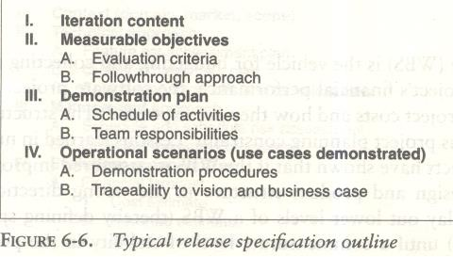

Release Descriptions
Release description documents describe the results of each release, including performance against each of the evaluation criteria in the corresponding release specification. Release baselines should be accompanied by a release description document that describes the evaluation criteria for that configuration baseline and provides substantiation (through demonstration, testing, inspection, or analysis) that each criterion has been addressed in an acceptable manner. Figure 6-7 provides a default outline for a release description.

Status Assessments
Status assessments provide periodic snapshots of project health and status, including the software project manager's risk assessment, quality indicators, and management indicators. Typical status assessments should include a review of resources, personnel staffing, financial data (cost and revenue), top 10 risks, technical progress (metrics snapshots), major milestone plans and results, total project or product scope & action items

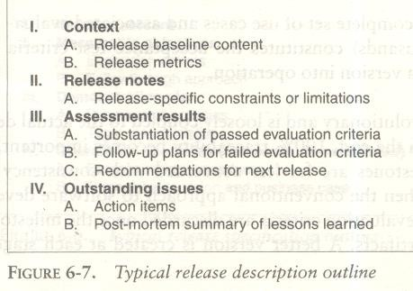

Environment
An important emphasis of a modern approach is to define the development and maintenance environment as a first-class artifact of the process. A robust, integrated development environment must support automation of the development process. This environment should include requirements management, visual modeling, document automation, host and target programming tools, automated regression testing, and continuous and integrated change management, and feature and defect tracking.

Deployment
A deployment document can take many forms. Depending on the project, it could include several document subsets for transitioning the product into operational status. In big contractual efforts in which the system is delivered to a separate maintenance organization, deployment artifacts may include computer system operations manuals, software installation manuals, plans and procedures for cutover (from a legacy system), site surveys, and so forth. For commercial software products, deployment artifacts may include marketing plans, sales rollout kits, and training courses.

Management Artifact Sequences
In each phase of the life cycle, new artifacts are produced and previously developed artifacts are updated to incorporate lessons learned and to capture further depth and breadth of the solution. Figure 6-8 identifies a typical sequence of artifacts across the life-cycle phases.

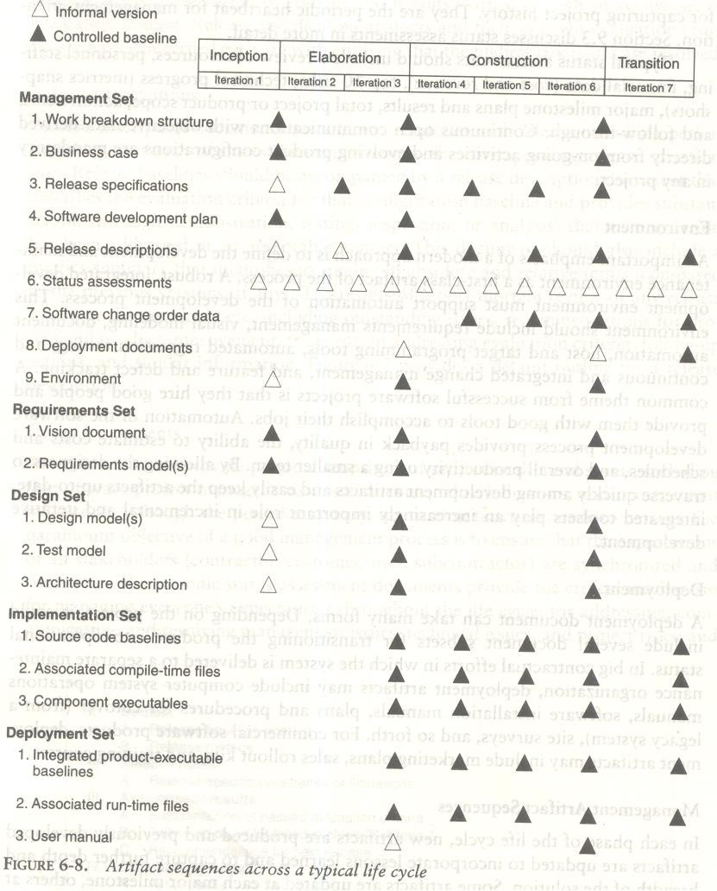

ENGINEERING ARTIFACTS
Most of the engineering artifacts are captured in rigorous engineering notations such as UML, programming languages, or executable machine codes. Three engineering artifacts are explicitly intended for more general review, and they deserve further elaboration.

Vision Document
The vision document provides a complete vision for the software system under development and. supports the contract between the funding authority and the development organization. A project vision is meant to be changeable as understanding evolves of the requirements, architecture, plans, and technology. A good vision document should change slowly. Figure 6-9 provides a default outline for a vision document.
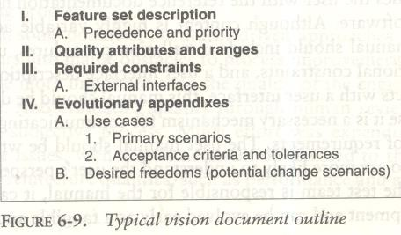

Architecture Description
The architecture description provides an organized view of the software architecture under development. It is extracted largely from the design model and includes views of the design, implementation, and deployment sets sufficient to understand how the operational concept of the requirements set will be achieved. The breadth of the architecture description will vary from project to project depending on many factors. Figure 6-10 provides a default outline for an architecture description.
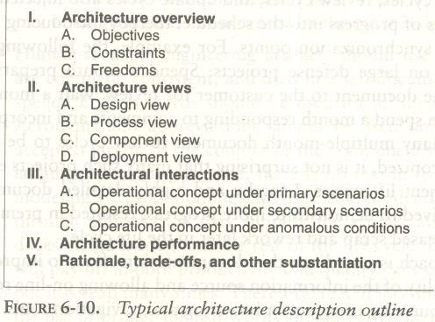

Software User Manual
The software user manual provides the user with the reference documentation necessary to support the delivered software. Although content is highly variable across application domains, the user manual should include installation procedures, usage procedures and guidance, operational constraints, and a user interface description, at a minimum. For software products with a user interface, this manual should be developed early in the life cycle because it is a necessary mechanism for communicating and stabilizing an important subset of requirements. The user manual should be written by members of the test team, who are more likely to understand the user's perspective than the development team.

PRAGMATIC ARTIFACTS
- People want to review information but don't understand the language of the artifact. Many interested reviewers of a particular artifact will resist having to learn the engineering language in which the artifact is written. It is not uncommon to find people (such as veteran software managers, veteran quality assurance specialists, or an auditing authority from a regulatory agency) who react as follows: "I'm not going to learn UML, but I want to review the design of this software, so give me a separate description such as some flowcharts and text that I can understand."
- People want to review the information but don't have access to the tools. It is not very common for the development organization to be fully tooled; it is extremely rare that the/other stakeholders have any capability to review the engineering artifacts on-line. Consequently, organizations are forced to exchange paper documents. Standardized formats (such as UML, spreadsheets, Visual Basic, C++, and Ada 95), visualization tools, and the Web are rapidly making it economically feasible for all stakeholders to exchange information
electronically.
- Human-readable engineering artifacts should use rigorous notations that are complete, consistent, and used in a self-documenting manner. Properly spelled English words should be used for all identifiers and descriptions. Acronyms and abbreviations should be used only where they are well accepted jargon in the context of the component's usage. Readability should be emphasized and the use of proper English words should be required in all engineering artifacts. This practice enables understandable representations, browse able formats (paperless review), more-rigorous notations, and reduced error rates.

Useful documentation is self-defining: It is documentation that gets used.
- Paper is tangible; electronic artifacts are too easy to change. On-line and Web-based artifacts can be changed easily and are viewed with more skepticism because of their inherent volatility.

Unit – III Important questions

1. | Explain briefly two stages of the life cycle engineering and production.
2. | Explain different phases of the life cycle process?
3. | Explain the goal of Inception phase, Elaboration phase, Construction phase and Transition phase.
4. | Explain the overview of the artifact set
5. | Write a short note on  (a) Management Artifacts (b) Engineering Artifacts (c) Pragmatic Artifacts

Model based software architecture

ARCHITECTURE: A MANAGEMENT PERSPECTIVE
The most critical technical product of a software project is its architecture: the infrastructure, control, and data interfaces that permit software components to cooperate as a system and software designers to cooperate efficiently as a team. When the communications media include multiple languages and intergroup literacy varies, the communications problem can become extremely complex and even unsolvable. If a software development team is to be successful, the inter project communications, as captured in the software architecture, must be both accurate and precise
From a management perspective, there are three different aspects of architecture.
    - An architecture (the intangible design concept) is the design of a software system this includes all engineering necessary to specify a complete bill of materials.
    - An architecture baseline (the tangible artifacts) is a slice of information across the engineering artifact sets sufficient to satisfy all stakeholders that the vision (function and quality) can be achieved within the parameters of the business case (cost, profit, time, technology, and people).
    - An architecture description (a human-readable representation of an architecture, which is one of the components of an architecture baseline) is an organized subset of information extracted from the design set model(s). The architecture description communicates how the intangible concept is realized in the tangible artifacts.
The number of views and the level of detail in each view can vary widely.
The importance of software architecture and its close linkage with modern software development processes can be summarized as follows:
- Achieving a stable software architecture represents a significant project milestone at which the critical make/buy decisions should have been resolved.
- Architecture representations provide a basis for balancing the trade-offs between the problem space (requirements and constraints) and the solution space (the operational product).
- The architecture and process encapsulate many of the important (high-payoff or high-risk) communications among individuals, teams, organizations, and stakeholders.
- Poor architectures and immature processes are often given as reasons for project failures.
- A mature process, an understanding of the primary requirements, and a demonstrable architecture are important prerequisites for predictable planning.
- Architecture development and process definition are the intellectual steps that map the problem to a solution without violating the constraints; they require human innovation and cannot be automated.

ARCHITECTURE: A TECHNICAL PERSPECTIVE
An architecture framework is defined in terms of views that are abstractions of the UML models in the design set. The design model includes the full breadth and depth of information. An architecture view is an abstraction of the design model; it contains only the architecturally significant information. Most real-world systems require four views: design, process, component, and deployment. The purposes of these views are as follows:
- Design: describes architecturally significant structures and functions of the design model
- Process: describes concurrency and control thread relationships among the design, component, and deployment views
- Component: describes the structure of the implementation set
- Deployment: describes the structure of the deployment set
Figure 7-1 summarizes the artifacts of the design set, including the architecture views and architecture description.

The requirements model addresses the behavior of the system as seen by its end users, analysts, and testers. This view is modeled statically using use case and class diagrams, and dynamically using sequence, collaboration, state chart, and activity diagrams.
- The use case view describes how the system's critical (architecturally significant) use cases are realized by elements of the design model. It is modeled statically using use case diagrams, and dynamically using any of the UML behavioral diagrams.
- The design view describes the architecturally significant elements of the design model. This view, an
abstraction of the design model, addresses the basic structure and functionality of the solution. It is modeled statically using class and object diagrams, and dynamically using any of the UML behavioral diagrams.
- The process view addresses the run-time collaboration issues involved in executing the architecture on a distributed deployment model, including the logical software network topology (allocation to processes and threads of control), interprocess communication, and state management. This view is modeled statically using deployment diagrams, and dynamically using any of the UML behavioral diagrams.
- The component view describes the architecturally significant elements of the implementation set. This view, an abstraction of the design model, addresses the software source code realization of the system from the perspective of the project's integrators and developers, especially with regard to releases and configuration management. It is modeled statically using component diagrams, and dynamically using any of the UML behavioral diagrams.
- The deployment view addresses the executable realization of the system, including the allocation of logical processes in the distribution view (the logical software topology) to physical resources of the deployment network (the physical system topology). It is modeled statically using deployment dia- grams, and dynamically using any of the UML behavioral diagrams.
Generally, an architecture baseline should include the following:
- Requirements: critical use cases, system-level quality objectives, and priority relationships among features and qualities
• Design: names, attributes, structures, behaviors, groupings, and relationships of significant classes and components
• Implementation: source component inventory and bill of materials (number, name, purpose, cost) of all primitive components
• Deployment: executable components sufficient to demonstrate the critical use cases and the risk associated with achieving the system qualities

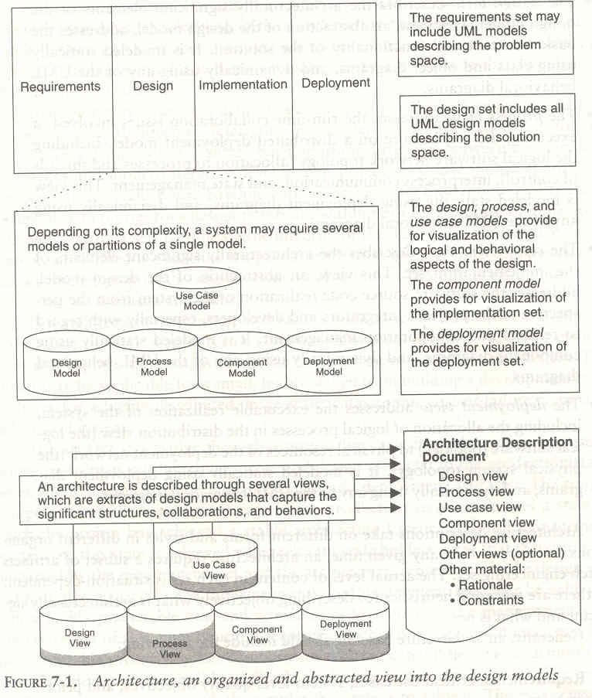

UNIT - IV
Work Flows of the process: Software process workflows, Iteration workflows.
Checkpoints of the process: Major mile stones, Minor Milestones, Periodic status assessments.
Iterative Process Planning: Work breakdown structures, planning guidelines, cost and schedule estimating, Iteration planning process, Pragmatic planning

Workflow of the process

SOFTWARE PROCESS WORKFLOWS
The term WORKFLOWS is used to mean a thread of cohesive and mostly sequential activities. Workflows are mapped to product artifacts There are seven top-level workflows:
    - Management workflow: controlling the process and ensuring win conditions for all stakeholders
    - Environment workflow: automating the process and evolving the maintenance environment
    - Requirements workflow: analyzing the problem space and evolving the requirements artifacts
    - Design workflow: modeling the solution and evolving the architecture and design artifacts
    - Implementation workflow: programming the components and evolving the implementation and deployment artifacts
    - Assessment workflow: assessing the trends in process and product quality
    - Deployment workflow: transitioning the end products to the user
Figure 8-1 illustrates the relative levels of effort expected across the phases in each of the top-level workflows.
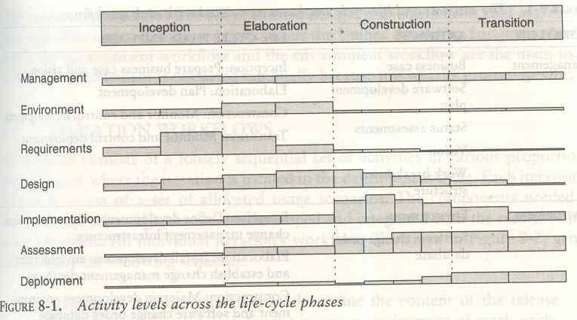

Table 8-1 shows the allocation of artifacts and the emphasis of each workflow in each of the life-cycle phases of inception, elaboration, construction, and transition.

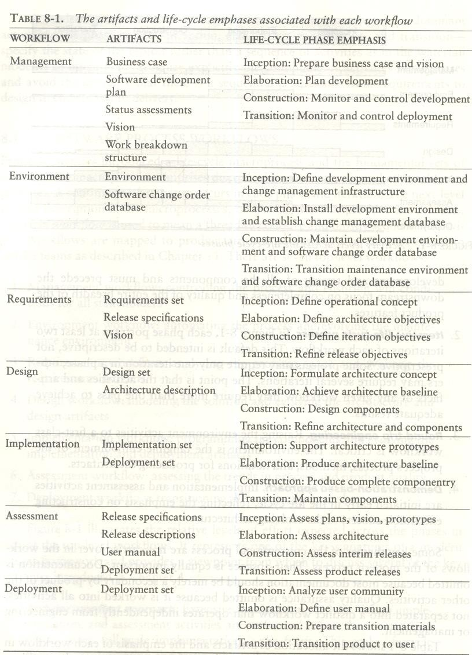

ITERATION WORKFLOWS
Iteration consists of a loosely sequential set of activities in various proportions, depending on where the iteration is located in the development cycle. Each iteration is defined in terms of a set of allocated usage scenarios. An individual iteration's workflow, illustrated in Figure 8-2, generally includes the following sequence:
- Management: iteration planning to determine the content of the release and develop the detailed plan for the iteration; assignment of work packages, or tasks, to the development team
- Environment: evolving the software change order database to reflect all new baselines and changes to existing baselines for all product, test, and environment components
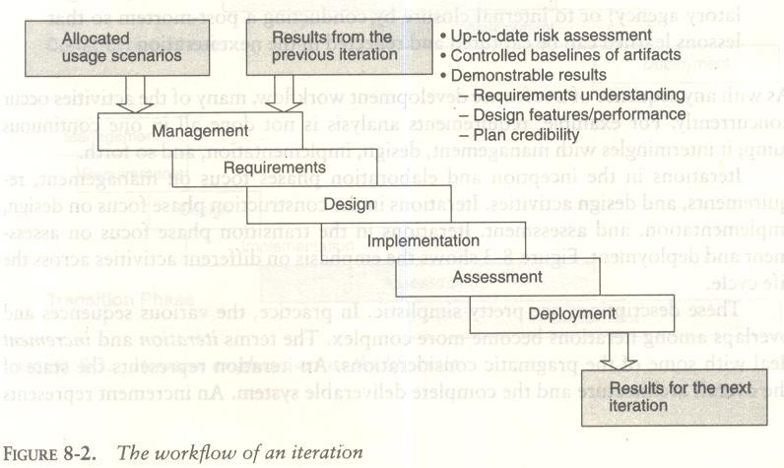
- Requirements: analyzing the baseline plan, the baseline architecture, and the baseline requirements set artifacts to fully elaborate the use cases to be demonstrated at the end of this iteration and their evaluation criteria; updating any requirements set artifacts to reflect changes necessitated by results of this iteration's engineering activities
- Design: evolving the baseline architecture and the baseline design set artifacts to elaborate fully the design model and test model components necessary to demonstrate against the evaluation criteria allocated to this iteration; updating design set artifacts to reflect changes necessitated by the results of this iteration's engineering activities

- Implementation: developing or acquiring any new components, and enhancing or modifying any existing components, to demonstrate the evaluation criteria allocated to this iteration; integrating and testing all new and modified components with existing baselines (previous versions)
- Assessment: evaluating the results of the iteration, including compliance with the allocated evaluation criteria and the quality of the current baselines; identifying any rework required and determining whether it should be performed before deployment of this release or allocated to the next release; assessing results to improve the basis of the subsequent iteration's plan
- Deployment: transitioning the release either to an external organization (such as a user, independent verification and validation contractor, or regulatory agency) or to internal closure by conducting a post-mortem so that lessons learned can be captured and reflected in the next iteration
Iterations in the inception and elaboration phases focus on management. Requirements, and design activities. Iterations in the construction phase focus on design, implementation, and assessment. Iterations in the transition phase focus on assessment and deployment. Figure 8-3 shows the emphasis on different activities across the life cycle. An iteration represents the state of the overall architecture and the complete deliverable system. An increment represents the current progress that will be combined with the preceding iteration to from the next iteration. Figure 8-4, an example of a simple development life cycle, illustrates the differences between iterations and increments.
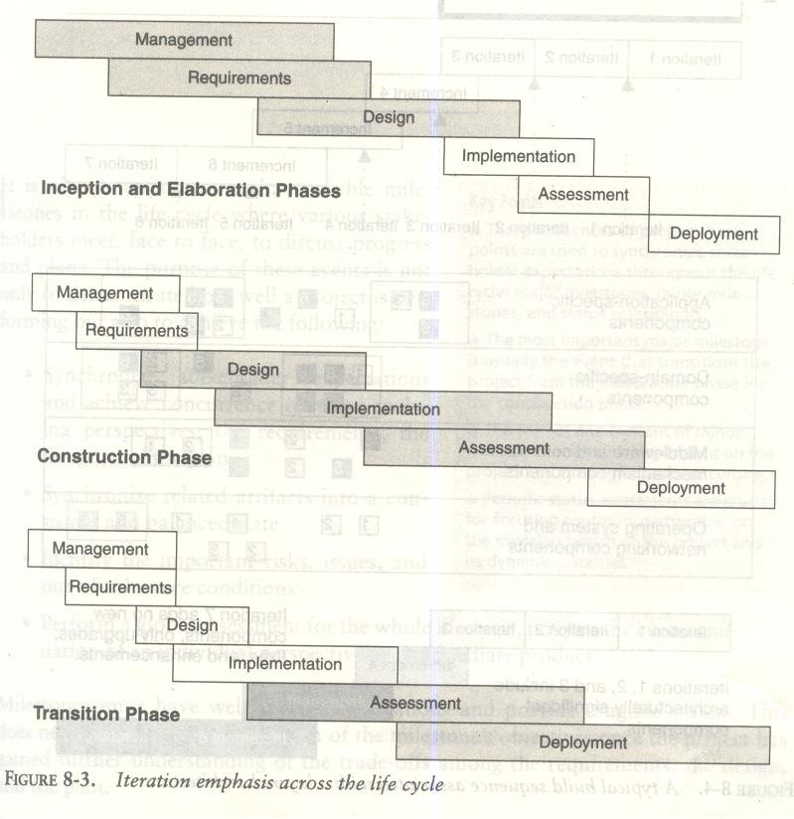

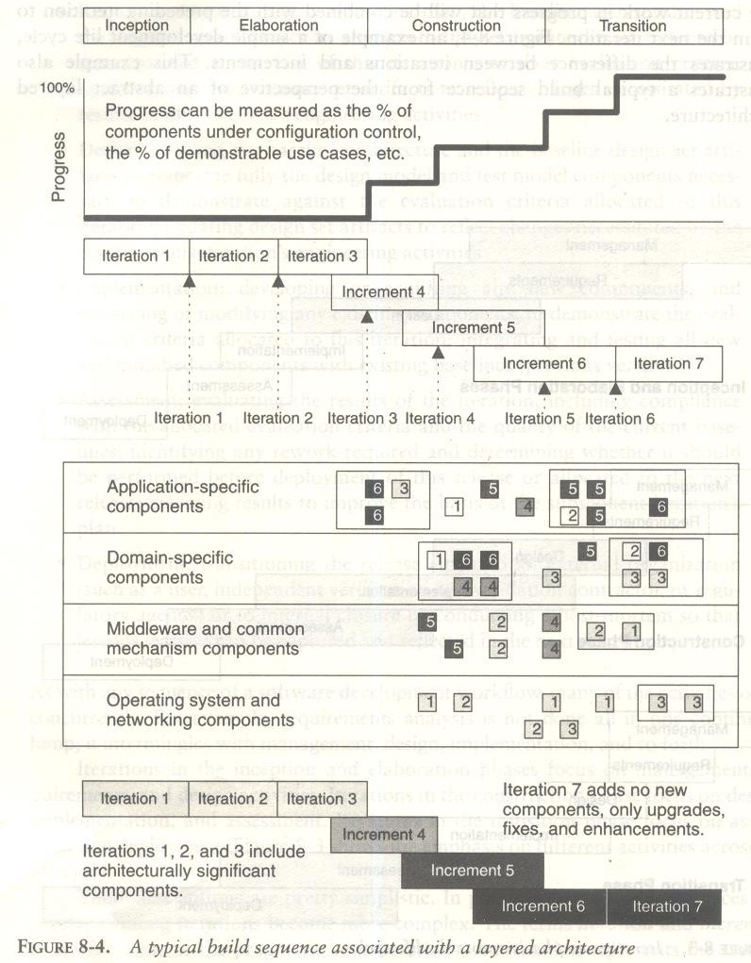

Checkpoints of the process
Three types of joint management reviews are conducted throughout the process:

  - Major milestones. These system wide events are held at the end of each development phase. They provide visibility to system wide issues, synchronize the management and engineering perspectives, and verify that the aims of the phase have been achieved.
  - Minor milestones. These iteration-focused events are conducted to review the content of an iteration in detail and to authorize continued work.
  - Status assessments. These periodic events provide management with frequent and regular insight into the progress being made.

Each of the four phases-inception, elaboration, construction, and transition consists of one or more iterations and concludes with a major milestone when a planned technical capability is produced in demonstrable form. An iteration represents a cycle of activities for which there is a well-defined intermediate result-a minor milestone-captured with two artifacts: a release specification (the evaluation criteria and plan) and a release description (the results). Major milestones at the end of each phase use formal, stakeholder-approved evaluation criteria and release descriptions; minor milestones use informal, development-team-controlled versions of these artifacts.
Figure 9-1 illustrates a typical sequence of project checkpoints for a relatively large project.
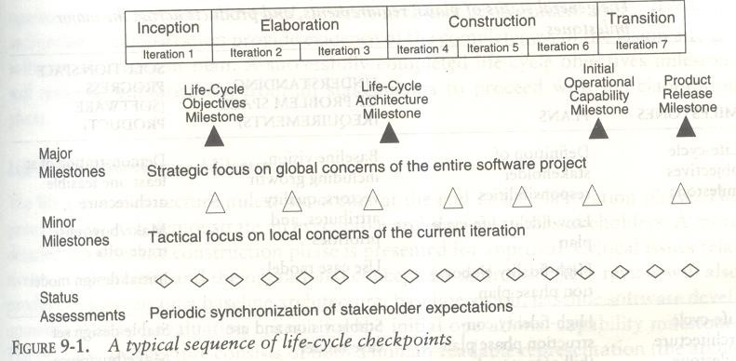

MAJOR MILESTONES
The four major milestones occur at the transition points between life-cycle phases. They can be used in many different process models, including the conventional waterfall model. In an iterative model, the major milestones are used to achieve concurrence among all stakeholders on the current state of the project. Different stakeholders have very different concerns:

    - Customers: schedule and budget estimates, feasibility, risk assessment, requirements understanding, progress, product line compatibility
    - Users: consistency with requirements and usage scenarios, potential for accommodating growth, quality attributes
    - Architects and systems engineers: product line compatibility, requirements changes, trade-off analyses, completeness and consistency, balance among risk, quality, and usability
    - Developers: sufficiency of requirements detail and usage scenario descriptions, . frameworks for component selection or development, resolution of development risk, product line compatibility, sufficiency of the development environment
    - Maintainers: sufficiency of product and documentation artifacts, understandability, interoperability with existing systems, sufficiency of maintenance environment
    - Others: possibly many other perspectives by stakeholders such as regulatory agencies, independent verification and validation contractors, venture capital investors, subcontractors, associate contractors, and sales and marketing teams
Table 9-1 summarizes the balance of information across the major milestones.
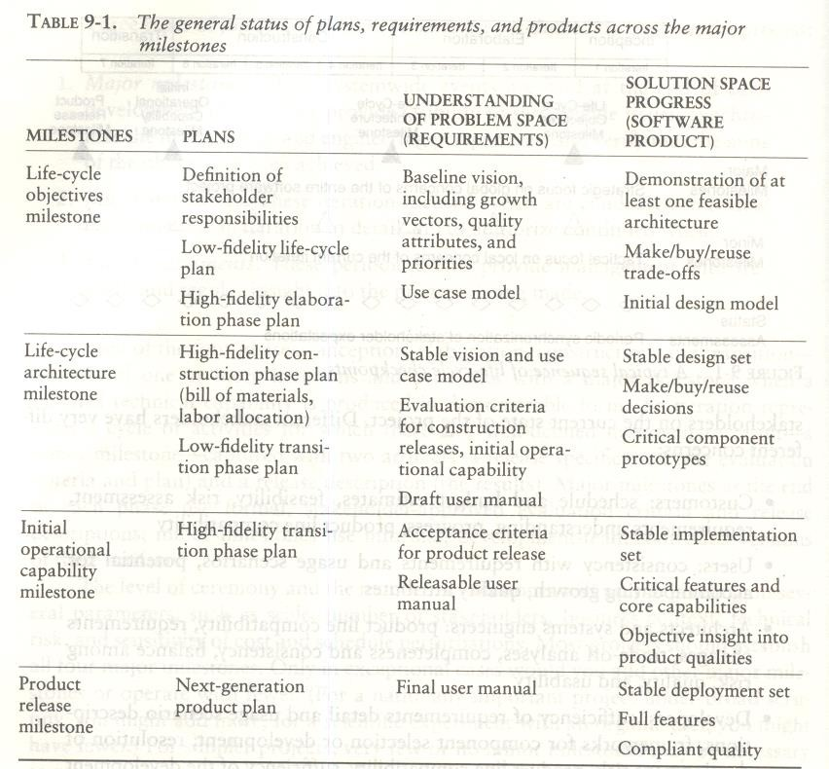

Life-Cycle Objectives Milestone
The life-cycle objectives milestone occurs at the end of the inception phase. The goal is to present to all stakeholders a recommendation on how to proceed with development, including a plan, estimated cost and schedule, and expected benefits and cost savings. A successfully completed life-cycle objectives milestone will result in authorization from all stakeholders to proceed with the elaboration phase.

Life-Cycle Architecture Milestone
The life-cycle architecture milestone occurs at the end of the elaboration phase. The primary goal is to demonstrate an executable architecture to all stakeholders. The baseline architecture consists of both a human- readable representation (the architecture document) and a configuration-controlled set of software components captured in the engineering artifacts. A successfully completed life-cycle architecture milestone will result in authorization from the stakeholders to proceed with the construction phase.
The technical data listed in Figure 9-2 should have been reviewed by the time of the lifecycle architecture milestone. Figure 9-3 provides default agendas for this milestone.
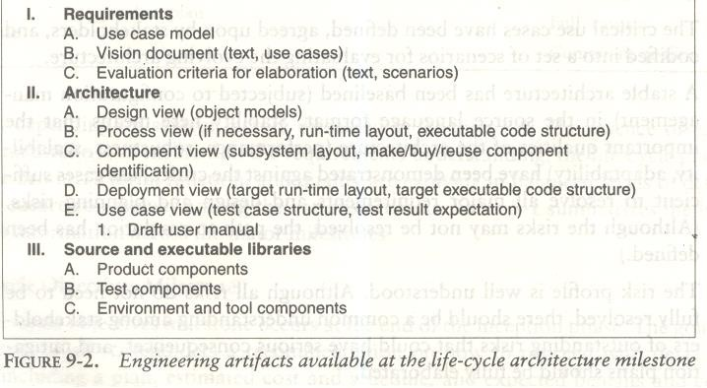
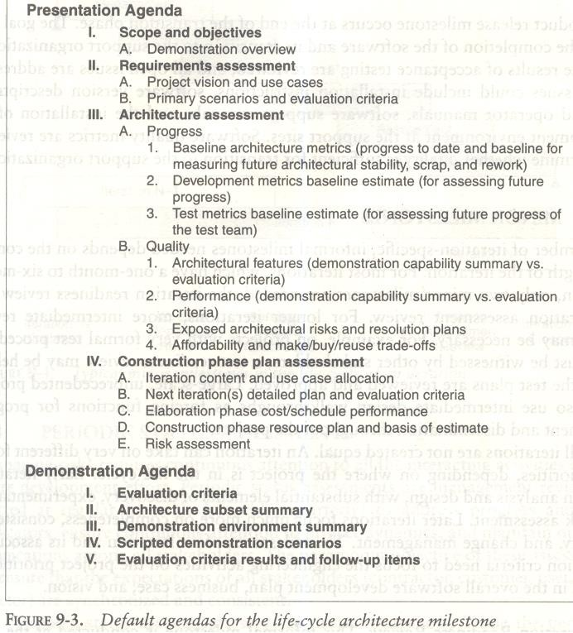

Initial Operational Capability Milestone
The initial operational capability milestone occurs late in the construction phase. The goals are to assess the readiness of the software to begin the transition into customer/user sites and to authorize the start of acceptance testing. Acceptance testing can be done incrementally across multiple iterations or can be completed entirely during the transition phase is not necessarily the completion of the construction phase.

Product Release Milestone
The product release milestone occurs at the end of the transition phase. The goal is to assess the completion of the software and its transition to the support organization, if any. The results of acceptance testing are reviewed, and all open issues are addressed. Software quality metrics are reviewed to determine whether quality is sufficient for transition to the support organization.

MINOR MILESTONES
For most iterations, which have a one-month to six-month duration, only two minor milestones are needed: the iteration readiness review and the iteration assessment review.
    - Iteration Readiness Review. This informal milestone is conducted at the start of each iteration to review the detailed iteration plan and the evaluation criteria that have been allocated to this iteration.
    - Iteration Assessment Review. This informal milestone is conducted at the end of each iteration to assess the degree to which the iteration achieved its objectives and satisfied its evaluation criteria, to review iteration results, to review qualification test results (if part of the iteration), to determine the amount of rework to be done, and to review the impact of the iteration results on the plan for subsequent iterations.
The format and content of these minor milestones tend to be highly dependent on the project and the organizational culture. Figure 9-4 identifies the various minor milestones to be considered when a project is being planned.
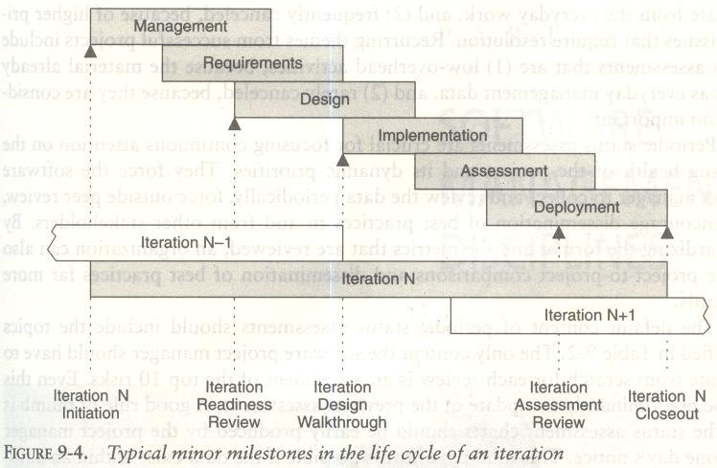

PERIODIC STATUS ASSESSMENTS
Periodic status assessments are management reviews conducted at regular intervals (monthly, quarterly) to address progress and quality indicators, ensure continuous attention to project dynamics, and maintain open communications among all stakeholders.
Periodic status assessments serve as project snapshots. While the period may vary, the recurring event forces the project history to be captured and documented. Status assessments provide the following:
    - A mechanism for openly addressing, communicating, and resolving management issues, technical issues, and project risks
    - Objective data derived directly from on-going activities and evolving product configurations
    - A mechanism for disseminating process, progress, quality trends, practices, and experience information to and from all stakeholders in an open forum
Periodic status assessments are crucial for focusing continuous attention on the evolving health of the project and its dynamic priorities. They force the software project manager to collect and review the data periodically, force outside peer review, and encourage dissemination of best practices to and from other stakeholders.

The default content of periodic status assessments should include the topics identified in Table 9-2.
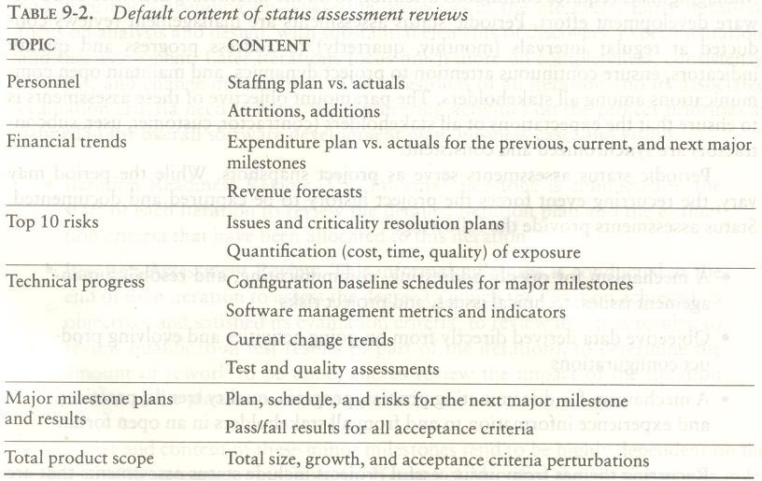

Iterative process planning
A good work breakdown structure and its synchronization with the process framework are critical factors in software project success. Development of a work breakdown structure dependent on the project management style, organizational culture, customer preference, financial constraints, and several other hard-to-define, project-specific parameters.
A WBS is simply a hierarchy of elements that decomposes the project plan into the discrete work tasks. A WBS provides the following information structure:

- A delineation of all significant work
- A clear task decomposition for assignment of responsibilities
- A framework for scheduling, budgeting, and expenditure tracking
Many parameters can drive the decomposition of work into discrete tasks: product subsystems, components, functions, organizational units, life-cycle phases, even geographies. Most systems have a first-level decomposition by subsystem. Subsystems are then decomposed into their components, one of which is typically the software.

CONVENTIONAL WBS ISSUES
Conventional work breakdown structures frequently suffer from three fundamental flaws.

      - They are prematurely structured around the product design.
      - They are prematurely decomposed, planned, and budgeted in either too much or too little detail.
      - They are project-specific, and cross-project comparisons are usually difficult or impossible.
Conventional work breakdown structures are prematurely structured around the product design. Figure 10-1 shows a typical conventional WBS that has been structured primarily around the subsystems of its product architecture, then further decomposed into the components of each subsystem. A WBS is the architecture for the financial plan.
Conventional work breakdown structures are prematurely decomposed, planned, and budgeted in either too little or too much detail. Large software projects tend to be over planned and small projects tend to be under planned. The basic problem with planning too much detail at the outset is that the detail does not evolve with the level of fidelity in the plan.
Conventional work breakdown structures are project-specific, and cross-project comparisons are usually difficult or impossible. With no standard WBS structure, it is extremely difficult to compare plans, financial data, schedule data, organizational efficiencies, cost trends, productivity trends, or quality trends across multiple projects.
Figure 10-1 Conventional work breakdown structure, following the product hierarchy

Management
System requirement and design Subsystem 1

Component 11 Requirements Design
Code Test

Documentation
…(similar structures for other components) Component 1N

Requirements Design
Code Test

Documentation
…(similar structures for other subsystems) Subsystem M

Component M1

Requirements Design

Code Test
Documentation

…(similar structures for other components) Component MN
Requirements Design

Code Test
Documentation Integration and test Test planning

Test procedure preparation Testing
Test reports

Other support areas Configuration control Quality assurance System administration

EVOLUTIONARY WORK BREAKDOWN STRUCTURES
An evolutionary WBS should organize the planning elements around the process framework rather than the product framework. The basic recommendation for the WBS is to organize the hierarchy as follows:
- First-level WBS elements are the workflows (management, environment, requirements, design, implementation, assessment, and deployment).
- Second-level elements are defined for each phase of the life cycle (inception, elaboration, construction, and transition).
- Third-level elements are defined for the focus of activities that produce the artifacts of each phase.
A default WBS consistent with the process framework (phases, workflows, and artifacts) is shown in Figure 10-2. This recommended structure provides one example of how the elements of the process framework can be integrated into a plan. It provides a framework for estimating the costs and schedules of each element, allocating them across a project organization, and tracking expenditures.
The structure shown is intended to be merely a starting point. It needs to be tailored to the specifics of a project in many ways.
- Scale. Larger projects will have more levels and substructures.
- Organizational structure. Projects that include subcontractors or span multiple organizational entities may introduce constraints that necessitate different WBS allocations.
- Degree of custom development. Depending on the character of the project, there can be very different emphases in the requirements, design, and implementation workflows.
- Business context. Projects developing commercial products for delivery to a broad customer base may require much more elaborate substructures for the deployment element.
- Precedent experience. Very few projects start with a clean slate. Most of them are developed as new generations of a legacy system (with a mature WBS) or in the context of existing organizational standards (with preordained WBS expectations).
The WBS decomposes the character of the project and maps it to the life cycle, the budget, and the

personnel. Reviewing a WBS provides insight into the important attributes, priorities, and structure of the project plan.
Another important attribute of a good WBS is that the planning fidelity inherent in each element is commensurate with the current life-cycle phase and project state. Figure 10-3 illustrates this idea. One of the primary reasons for organizing the default WBS the way I have is to allow for planning elements that range from planning packages (rough budgets that are maintained as an estimate for future elaboration rather than being decomposed into detail) through fully planned activity networks (with a well-defined budget and continuous assessment of actual versus planned expenditures).

Figure 10-2 Default work breakdown structure A Management
AA Inception phase management AAA Business case development
AAB Elaboration phase release specifications AAC Elaboration phase WBS specifications AAD Software development plan
AAE Inception phase project control and status assessments AB Elaboration phase management
ABA Construction phase release specifications ABB Construction phase WBS baselining
ABC Elaboration phase project control and status assessments AC Construction phase management
ACA Deployment phase planning
ACB Deployment phase WBS baselining
ACC Construction phase project control and status assessments AD Transition phase management
ADA Next generation planning
ADB Transition phase project control and status assessments B Environment
BA Inception phase environment specification BB Elaboration phase environment baselining
BBA Development environment installation and administration BBB Development environment integration and custom toolsmithing BBC SCO database formulation
BC Construction phase environment maintenance
BCA Development environment installation and administration BCB SCO database maintenance
BD Transition phase environment maintenance
BDA Development environment maintenance and administration BDB SCO database maintenance
BDC Maintenance environment packaging and transition C Requirements
CA Inception phase requirements development CCA Vision specification
CAB Use case modeling

CB Elaboration phase requirements baselining CBA Vision baselining
CBB Use case model baselining
CC Construction phase requirements maintenance CD Transition phase requirements maintenance
D Design
DA Inception phase architecture prototyping DB Elaboration phase architecture baselining DBA Architecture design modeling
DBB Design demonstration planning and conduct DBC Software architecture description
DC Construction phase design modeling
DCA Architecture design model maintenance DCB Component design modeling
DD Transition phase design maintenance E Implementation
EA Inception phase component prototyping
EB Elaboration phase component implementation
EBA Critical component coding demonstration integration EC Construction phase component implementation
ECA Initial release(s) component coding and stand-alone testing ECB Alpha release component coding and stand-alone testing ECC Beta release component coding and stand-alone testing
ECD Component maintenance F Assessment
FA Inception phase assessment FB Elaboration phase assessment
FBA Test modeling
FBB Architecture test scenario implementation
FBC Demonstration assessment and release descriptions FC Construction phase assessment
FCA Initial release assessment and release description FCB Alpha release assessment and release description FCC Beta release assessment and release description
FD Transition phase assessment
FDA Product release assessment and release description G Deployment
GA Inception phase deployment planning GB Elaboration phase deployment planning GC Construction phase deployment
GCA User manual baselining GD Transition phase deployment
GDA Product transition to user

Figure 10-3 Evolution of planning fidelity in the WBS over the life cycle

Inception Elaboration

WBS Element Fidelity WBS Element Fidelity Management High Management High Environment Moderate Environment High Requirement High Requirement High Design Moderate Design High Implementation Low Implementation Moderate
Assessment Low Assessment Moderate
Deployment Low Deployment Low

WBS Element | Fidelity | WBS Element | Fidelity
Management | High | Management | High
Environment | High | Environment | High
Requirements | Low | Requirements | Low
Design | Low | Design | Moderate
Implementation | Moderate | Implementation | High
Assessment | High | Assessment | High
Deployment | High | Deployment | Moderate

Transition Construction

PLANNING GUIDELINES
Software projects span a broad range of application domains. It is valuable but risky to make specific planning recommendations independent of project context. Project-independent planning advice is also risky. There is the risk that the guidelines may pe adopted blindly without being adapted to specific project circumstances. Two simple planning guidelines should be considered when a project plan is being initiated or assessed. The first guideline, detailed in Table 10-1, prescribes a default allocation of costs among the first-level WBS elements. The second guideline, detailed in Table 10-2, prescribes the allocation of effort and schedule across the lifecycle phases.

10-1 Web budgeting defaults
First Level WBS Element | Default Budget
Management | 10%
Environment | 10%
Requirement | 10%
Design | 15%
Implementation | 25%
Assessment | 25%
Deployment | 5%
Total | 100%
Table 10-2 Default distributions of effort and schedule by phase
Domain | Inception | Elaboration | Construction | Transition
Effort | 5% | 20% | 65% | 10%
Schedule | 10% | 30% | 50% | 10%

THE COST AND SCHEDULE ESTIMATING PROCESS
Project plans need to be derived from two perspectives. The first is a forward-looking, top-down approach. It starts with an understanding of the general requirements and constraints, derives a macro-level budget and schedule, then decomposes these elements into lower level budgets and intermediate milestones. From this perspective, the following planning sequence would occur:

    - The software project manager (and others) develops a characterization of the overall size, process, environment, people, and quality required for the project.
    - A macro-level estimate of the total effort and schedule is developed using a software cost estimation model.
    - The software project manager partitions the estimate for the effort into a top-level WBS using guidelines such as those in Table 10-1.
    - At this point, subproject managers are given the responsibility for decomposing each of the WBS elements into lower levels using their top-level allocation, staffing profile, and major milestone dates as constraints.

The second perspective is a backward-looking, bottom-up approach. We start with the end in mind, analyze the micro-level budgets and schedules, then sum all these elements into the higher level budgets and intermediate milestones. This approach tends to define and populate the WBS from the lowest levels upward. From this per- spective, the following planning sequence would occur:
- The lowest level WBS elements are elaborated into detailed tasks
- Estimates are combined and integrated into higher level budgets and milestones.
- Comparisons are made with the top-down budgets and schedule milestones.
Milestone scheduling or budget allocation through top-down estimating tends to exaggerate the project management biases and usually results in an overly optimistic plan. Bottom-up estimates usually exaggerate the performer biases and result in an overly pessimistic plan.
These two planning approaches should be used together, in balance, throughout the life cycle of the project. During the engineering stage, the top-down perspective will dominate because there is usually not enough depth of understanding nor stability in the detailed task sequences to perform credible bottom-up planning. During the production stage, there should be enough precedent experience and planning fidelity that the bottom-up planning perspective will dominate. Top-down approach should be well tuned to the project-

specific parameters, so it should be used more as a global assessment technique. Figure 10-4 illustrates this life- cycle planning balance.

Figure 10-4 Planning balance throughout the life cycle

Bottom up task level planning based on metrics from previous iterations

Top down project level planning based on microanalysis from previous projects

Engineering Stage |  | Production Stage
Inception | Elaboration | Construction | Transition

Feasibility iteration Architecture iteration Usable iteration Product
Releases

Engineering stage planning emphasis | Production stage planning emphasis
Macro level task estimation for production stage artifacts | Micro level task estimation for production stage artifacts
Micro level task estimation for engineering artifacts | Macro level task estimation for maintenance of engineering artifacts
Stakeholder concurrence | Stakeholder concurrence
Coarse grained variance analysis of actual vs planned expenditures | Fine grained variance analysis of actual vs planned expenditures
Tuning the top down project independent planning guidelines into project specific planning guidelines
WBS definition and elaboration

THE ITERATION PLANNING PROCESS
Planning is concerned with defining the actual sequence of intermediate results. An evolutionary build plan is important because there are always adjustments in build content and schedule as early conjecture evolves into well-understood project circumstances. Iteration is used to mean a complete synchronization across the project, with a well-orchestrated global assessment of the entire project baseline.
- Inception iterations. The early prototyping activities integrate the foundation components of a
candidate architecture and provide an executable framework for elaborating the critical use cases of the system. This framework includes existing components, commercial components, and custom prototypes sufficient to demonstrate a candidate architecture and sufficient requirements understanding to establish a credible business case, vision, and software development plan.
- Elaboration iterations. These iterations result in architecture, including a complete framework and infrastructure for execution. Upon completion of the architecture iteration, a few critical use cases should

be demonstrable: (1) initializing the architecture, (2) injecting a scenario to drive the worst-case data processing flow through the system (for example, the peak transaction throughput or peak load scenario), and (3) injecting a scenario to drive the worst-case control flow through the system (for example, orchestrating the fault-tolerance use cases).
- Construction iterations. Most projects require at least two major construction iterations: an alpha release and a beta release.
- Transition iterations. Most projects use a single iteration to transition a beta release into the final product.
The general guideline is that most projects will use between four and nine iterations. The typical project would have the following six-iteration profile:
  - One iteration in inception: an architecture prototype
  - Two iterations in elaboration: architecture prototype and architecture baseline
  - Two iterations in construction: alpha and beta releases
  - One iteration in transition: product release
A very large or unprecedented project with many stakeholders may require additional inception iteration and two additional iterations in construction, for a total of nine iterations.

PRAGMATIC PLANNING
Even though good planning is more dynamic in an iterative process, doing it accurately is far easier. While executing iteration N of any phase, the software project manager must be monitoring and controlling against a plan that was initiated in iteration N - 1 and must be planning iteration N + 1. The art of good project· management is to make trade-offs in the current iteration plan and the next iteration plan based on objective results in the current iteration and previous iterations. Aside from bad architectures and misunderstood requirements, inadequate planning (and subsequent bad management) is one of the most common reasons for project failures. Conversely, the success of every successful project can be attributed in part to good planning.
A project's plan is a definition of how the project requirements will be transformed into' a product within the business constraints. It must be realistic, it must be current, it must be a team product, it must be understood by the stakeholders, and it must be used. Plans are not just for managers. The more open and visible the planning process and results, the more ownership there is among the team members who need to execute it. Bad, closely held plans cause attrition. Good, open plans can shape cultures and encourage teamwork.

Unit – Important Questions

1. | Define Model-Based software architecture?
2. | Explain various process workflows?
3. | Define typical sequence of life cycle checkpoints?
4. | Explain general status of plans, requirements and product across the major milestones.
5. | Explain conventional and Evolutionary work break down structures?
6. | Explain briefly planning balance throughout the life cycle?

UNIT - V
Project Organizations and Responsibilities: Line-of-Business Organizations, Project Organizations, evolution of Organizations.
Process Automation: Automation Building blocks, The Project Environment.

Project Organizations and Responsibilities:
- Organizations engaged in software Line-of-Business need to support projects with the infrastructure necessary to use a common process.
- Project organizations need to allocate artifacts & responsibilities across project team to ensure a balance of global (architecture) & local (component) concerns.
- The organization must evolve with the WBS & Life cycle concerns.

Software lines of business & product teams have different motivation.
- Software lines of business are motivated by return of investment (ROI), new business discriminators, market diversification & profitability.
- Project teams are motivated by the cost, Schedule & quality of specific deliverables
- Line-Of-Business Organizations:
The main features of default organization are as follows:
  - Responsibility for process definition & maintenance is specific to a cohesive line of business.
- Responsibility for process automation is an organizational role & is equal in importance to the process definition role.
  - Organizational role may be fulfilled by a single individual or several different teams.
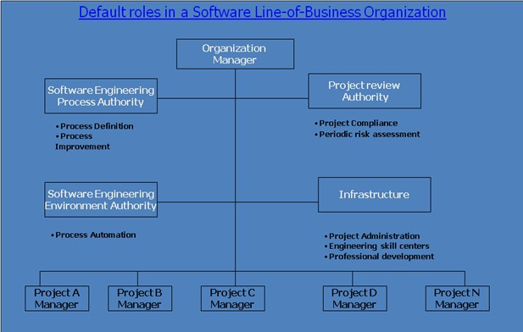
Fig: Default roles in a software Line-of-Business Organization.

Software Engineering Process Authority (SEPA)
The SEPA facilities the exchange of information & process guidance both to & from project practitioners
This role is accountable to General Manager for maintaining a current assessment of the organization’s process maturity & its plan for future improvement

Project Review Authority (PRA)
The PRA is the single individual responsible for ensuring that a software project complies with all organizational & business unit software policies, practices & standards
A software Project Manager is responsible for meeting the requirements of a contract or some other project compliance standard

Software Engineering Environment Authority( SEEA )
The SEEA is responsible for automating the organization’s process, maintaining the organization’s standard environment, Training projects to use the environment & maintaining organization-wide reusable assets
The SEEA role is necessary to achieve a significant ROI for common process.

Infrastructure
An organization’s infrastructure provides human resources support, project-independent research & development, & other capital software engineering assets.
- Project organizations:
Software Management
Artifacts
Activities
- Business case
- Software development plan
- Status assessments
Customer interface, PRA interface
Planning, monitoring Risk management
Software process definition Process improvement
System engineering
Administration
Software Architecture
Software Development
Software Assessment
Figure 11-2. Default project organization and responsibilities

  - The above figure shows a default project organization and maps project-level roles and responsibilities.
  - The main features of the default organization are as follows:
  - The project management team is an active participant, responsible for producing as well as managing.

  - The architecture team is responsible for real artifacts and for the integration of components, not just for staff functions.
  - The development team owns the component construction and maintenance activities.
  - The assessment team is separate from development.
  - Quality is everyone’s into all activities and checkpoints.
  - Each team takes responsibility for a different quality perspective.
- EVOLUTION OF ORGANIZATIONS:
Software Management 50%  Software Software Software Architecture Development Assessment 20% 20% 10%  Inception |  |  |  | Software Management 10%  Software Software Software Architecture Development Assessment 50% 20% 20%  Elaboration
Software Management 10%  Software Software Software Architecture Development Assessment 5% 35% 50%  Transition |  |  |  | Software Management 10%  Software Software Software Architecture Development Assessment 10% 50% 30%  Construction

Inception:  Software management: 50%  Software Architecture: 20%  Software development: 20%  Software Assessment (measurement/evaluation):10% | Elaboration:  Software management: 10%  Software Architecture: 50%  Software development: 20%  Software Assessment (measurement/evaluation):20%
Construction:  Software management: 10%  Software Architecture: 10%  Software development: 50%  Software Assessment (measurement/evaluation):30% | Transition:  Software management: 10%  Software Architecture: 5%  Software development: 35% Software Assessment  (measurement/evaluation):50%

Introductory Remarks:

The Process Automation:

The environment must be the first-class artifact of the process.
Process automation & change management is critical to an iterative process. If the change is expensive then the development organization will resist it.
Round-trip engineering & integrated environments promote change freedom & effective evolution of technical artifacts.
Metric automation is crucial to effective project control.
External stakeholders need access to environment resources to improve interaction with the development team & add value to the process.
The three levels of process which requires a certain degree of process automation for the corresponding process to be carried out efficiently.
Metaprocess (Line of business): The automation support for this level is called an infrastructure. Macroproces (project): The automation support for a project’s process is called an environment. Microprocess (iteration): The automation support for generating artifacts is generally called a tool.

Tools: Automation Building blocks:
Many tools are available to automate the software development process. Most of the core software development tools map closely to one of the process workflows

Workflows Environment Tools & process Automation Management Workflow automation, Metrics automation
Environment Change Management, Document Automation

Requirements Requirement Management
Design Visual Modeling

Implementation -Editors, Compilers, Debugger, Linker, Runtime Assessment -Test automation, defect Tracking
Deployment defect Tracking
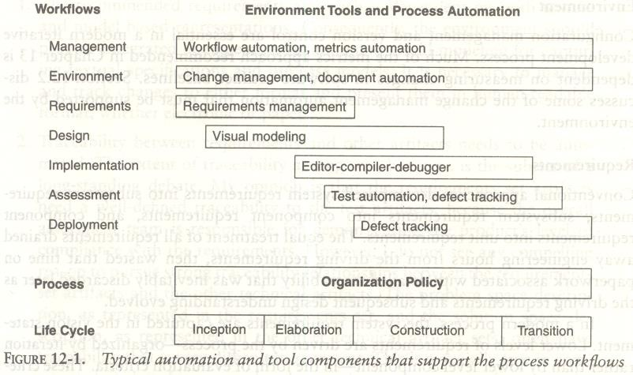

The Project Environment:
The project environment artifacts evolve through three discrete states.
(1) Prototyping Environment. (2) Development Environment. (3) Maintenance Environment.
The Prototype Environment includes an architecture test bed for prototyping project architecture to evaluate trade-offs during inception & elaboration phase of the life cycle.
The Development environment should include a full suite of development tools needed to support various Process workflows & round-trip engineering to the maximum extent possible.
The Maintenance Environment should typically coincide with the mature version of the development.
There are four important environment disciplines that are critical to management context & the success of a modern iterative development process.
Round-Trip engineering Change Management Software Change Orders (SCO)
Configuration baseline Configuration Control Board
Infrastructure Organization Policy Organization Environment Stakeholder Environment.

Round Trip Environment
Tools must be integrated to maintain consistency & traceability.
Round-Trip engineering is the term used to describe this key requirement for environment that support iterative development.
As the software industry moves into maintaining different information sets for the engineering artifacts, more automation support is needed to ensure efficient & error free transition of data from one artifacts to another.
Round-trip engineering is the environment support necessary to maintain Consistency among the engineering artifacts.
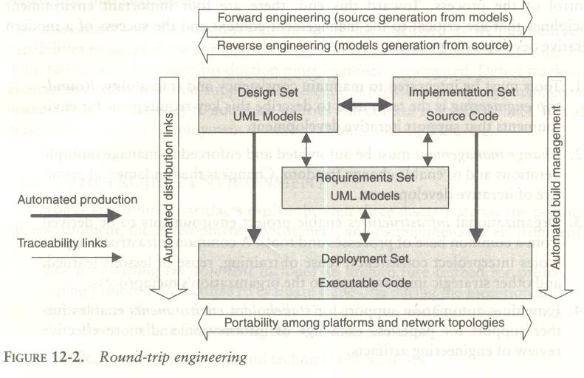

Change Management
Change management must be automated & enforced to manage multiple iterations & to enable change freedom. Change is the fundamental primitive of iterative Development.

Software Change Orders
The atomic unit of software work that is authorized to create, modify or obsolesce components within a configuration baseline is called a software change orders ( SCO )
The basic fields of the SCO are Title, description, metrics, resolution, assessment & disposition
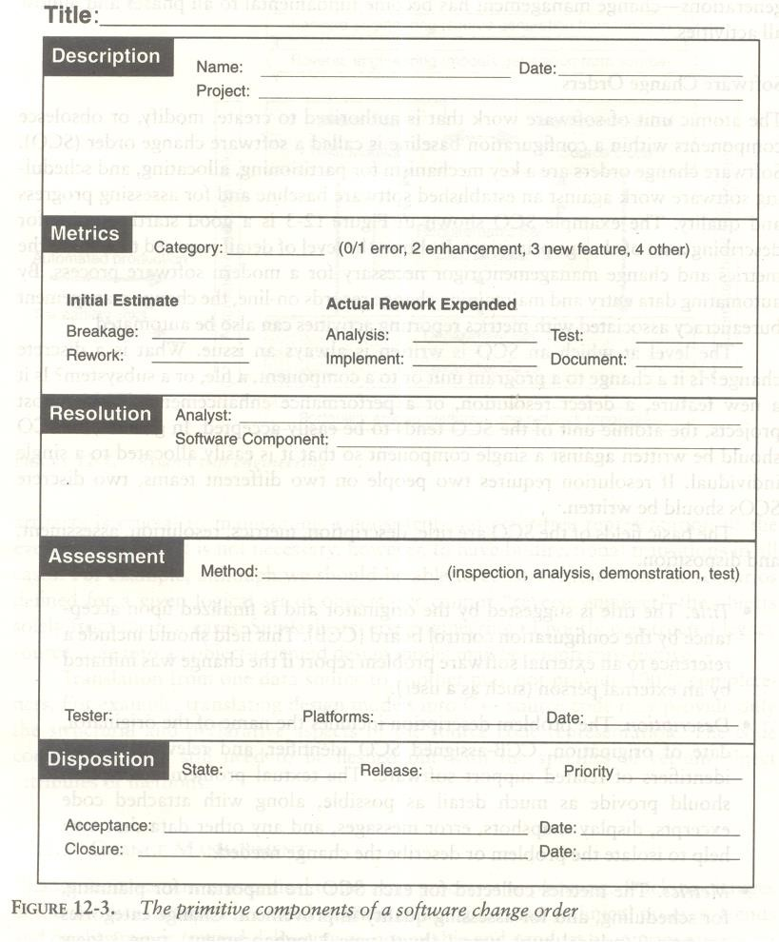
Change management
- Configuration Baseline
A configuration baseline is a named collection of software components &Supporting documentation that is subjected to change management & is upgraded, maintained, tested, statuses & obsolesced a unit There are generally two classes of baselines

External Product Release Internal testing Release
Three levels of baseline releases are required for most Systems

  - Major release (N)
  - Minor Release (M)
  - Interim (temporary) Release (X)
Major release represents a new generation of the product or project
A minor release represents the same basic product but with enhanced features, performance or quality. Major & Minor releases are intended to be external product releases that are persistent & supported for a period of time.
An interim release corresponds to a developmental configuration that is intended to be transient.
Once software is placed in a controlled baseline all changes are tracked such that a distinction must be made for the cause of the change. Change categories are
Type 0: Critical Failures (must be fixed before release)
Type 1: A bug or defect either does not impair (Harm) the usefulness of the system or can be worked around
Type 2: A change that is an enhancement rather than a response to a defect Type 3: A change that is necessitated by the update to the environment Type 4: Changes that are not accommodated by the other categories.

Change Management
III Configuration Control Board (CCB)
A CCB is a team of people that functions as the decision Authority on the content of configuration baselines
A CCB includes:

Software managers
- Software Architecture managers

Software Development managers
- Software Assessment managers

Other Stakeholders who are integral to the maintenance of the controlled software delivery system?
Infrastructure
The organization infrastructure provides the organization’s capital assets including two key artifacts - Policy & Environment

I Organization Policy:
A Policy captures the standards for project software development processes
The organization policy is usually packaged as a handbook that defines the life cycles & the process primitives such as

  - Major milestones
  - Intermediate Artifacts
  - Engineering repositories
  - Metrics
  - Roles & Responsibilities

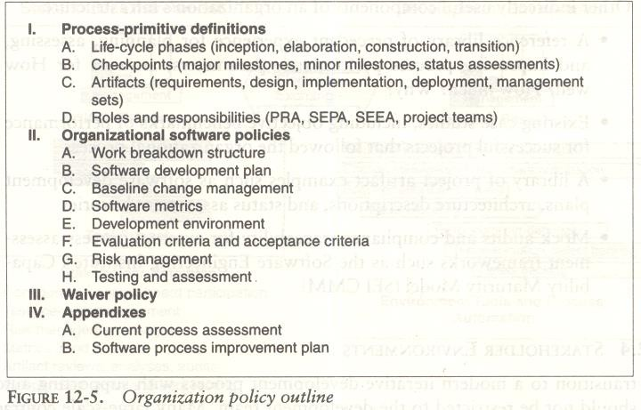

Infrastructure
II Organization Environment
The Environment that captures an inventory of tools which are building blocks from which project environments can be configured efficiently & economically

Stakeholder Environment
Many large scale projects include people in external organizations that represent other stakeholders participating in the development process they might include

  - Procurement agency contract monitors
  - End-user engineering support personnel
  - Third party maintenance contractors
  - Independent verification & validation contractors
  - Representatives of regulatory agencies & others.

These stakeholder representatives also need to access to development resources so that they can contribute value to overall effort. These stakeholders will be access through on-line
An on-line environment accessible by the external stakeholders allow them to participate in the process a follows
Accept & use executable increments for the hands-on evaluation.
Use the same on-line tools, data & reports that the development organization uses to manage & monitor the project
Avoid excessive travel, paper interchange delays, format translations, paper * shipping costs & other overhead cost

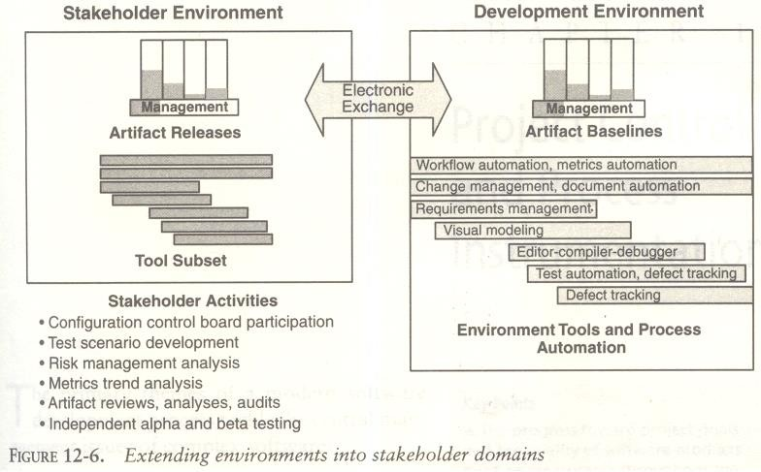

PROJECT CONTROL & PROCESS INSTRUMENTATION

INTERODUCTION: Software metrics are used to implement the activities and products of the software development process. Hence, the quality of the software products and the achievements in the development process can be determined using the software metrics.

Need for Software Metrics:
- Software metrics are needed for calculating the cost and schedule of a software product with
- great accuracy.
- Software metrics are required for making an accurate estimation of the progress.
- The metrics are also required for understanding the quality of the software product.

INDICATORS:
An indicator is a metric or a group of metrics that provides an understanding of the software process or software product or a software project. A software engineer assembles measures and produce metrics from which the indicators can be derived.
Two types of indicators are:
- Management indicators.
- Quality indicators.

Management Indicators
The management indicators i.e., technical progress, financial status and staffing progress are
used to determine whether a project is on budget and on schedule. The management indicators that indicate financial status are based on earned value system.

Quality Indicators
The quality indicators are based on the measurement of the changes occurred in software.

SEVEN CORE METRICS OF SOFTWARE PROJECT
Software metrics instrument the activities and products of the software
development/integration process. Metrics values provide an important perspective for managing the process. The most useful metrics are extracted directly from the evolving artifacts.
There are seven core metrics that are used in managing a modern process.

Seven core metrics related to project control:

Management Indicators Quality Indicators
- Work and Progress Change traffic and stability
- Budgeted cost and expenditures Breakage and modularity
- Staffing and team dynamics Rework and adaptability
□ Mean time between failures (MTBF) and maturity

MANAGEMENT INDICATORS:
Work and progress
This metric measure the work performed over time. Work is the effort to be accomplished to complete a certain set of tasks. The various activities of an iterative development project can be measured by defining a planned estimate of the work in an objective measure, then tracking progress (work completed overtime) against that plan.

The default perspectives of this metric are:
Software architecture team: - Use cases demonstrated.
Software development team: - SLOC under baseline change management, SCOs closed Software assessment team: - SCOs opened, test hours executed and evaluation criteria meet. Software management team: - milestones completed.

The below figure shows expected progress for a typical project with three major releases

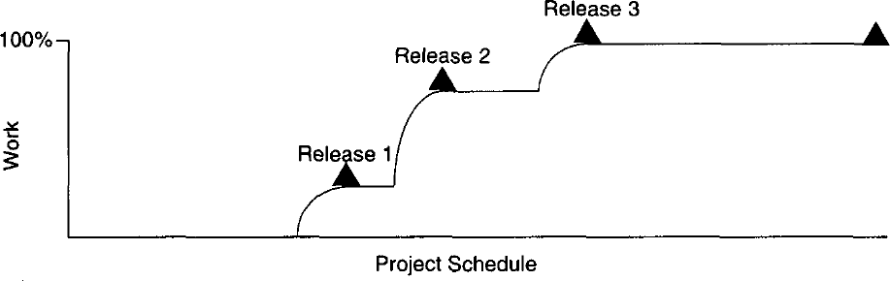
Fig: work and progress

Budgeted cost and expenditures
This metric measures cost incurred over time. Budgeted cost is the planned expenditure profile over the life cycle of the project. To maintain management control, measuring cost expenditures over the project life cycle is always necessary. Tracking financial progress takes on an organization - specific format. Financial performance can be measured by the use of an earned value system, which provides highly detailed cost and schedule insight. The basic parameters of an earned value system, expressed in units of dollars, are as follows:
Expenditure Plan - It is the planned spending profile for a project over its planned schedule. Actual progress - It is the technical accomplishment relative to the planned progress underlying the spending profile.
Actual cost: It is the actual spending profile for a project over its actual schedule. Earned value: It is the value that represents the planned cost of the actual progress. Cost variance: It is the difference between the actual cost and the earned value.
Schedule variance: It is the difference between the planned cost and the earned value. Of all parameters in an earned value system, actual progress is the most subjective
Assessment: Because most managers know exactly how much cost they have incurred and how much schedule they have used, the variability in making accurate assessments is centred in the actual progress assessment. The default perspectives of this metric are cost per month, full-time staff per month and percentage of budget expended.

Staffing and team dynamics
This metric measures the personnel changes over time, which involves staffing additions and reductions over time. An iterative development should start with a small team until the risks in the requirements and architecture have been suitably resolved. Depending on the overlap of iterations and other project specific circumstances, staffing can vary. Increase in staff can slow overall project progress as new people consume the productive team of existing people in coming up to speed. Low attrition of good people is a sign of success. The default perspectives of this metric are people per month added and people per month leaving. These three management indicators are responsible for technical progress, financial status and staffing progress.

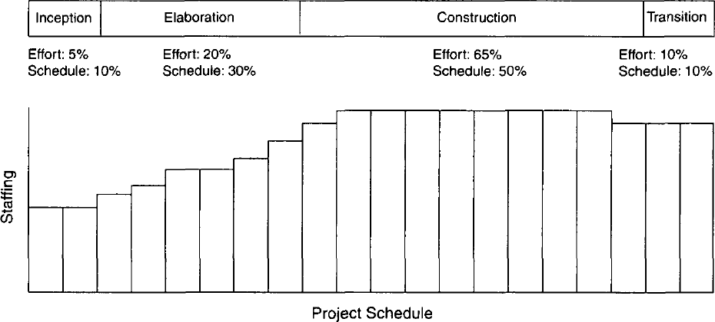
Fig: staffing and Team dynamics

QUALITY INDICATORS:
Change traffic and stability:
This metric measures the change traffic over time. The number of software change orders opened and closed over the life cycle is called change traffic. Stability specifies the relationship between opened versus closed software change orders. This metric can be collected by change type, by release, across all releases, by term, by components, by subsystems, etc.

The below figure shows stability expectation over a healthy project’s life cycle

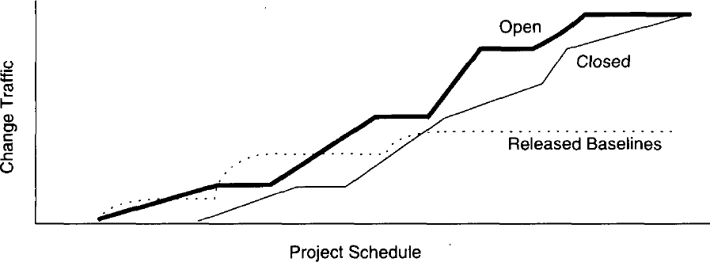
Fig: Change traffic and stability

Breakage and modularity
This metric measures the average breakage per change over time. Breakage is defined as the average extent of change, which is the amount of software baseline that needs rework and measured in source lines of code, function points, components, subsystems, files or other units. Modularity is the average breakage trend over time. This metric can be collected by revoke SLOC per change, by change type, by release, by components and by subsystems.

Rework and adaptability:
This metric measures the average rework per change over time. Rework is defined as the average cost of change which is the effort to analyse, resolve and retest all changes to software baselines. Adaptability is defined as the rework trend over time. This metric provides insight into rework measurement. All changes are not created equal. Some changes can be made in a staff- hour, while others take staff-weeks. This metric can be collected by average hours per change, by change type, by release, by components and by subsystems.
MTBF and Maturity:
This metric measures defect rather over time. MTBF (Mean Time Between Failures) is the average usage time between software faults. It is computed by dividing the test hours by the number of type 0 and type 1 SCOs. Maturity is defined as the MTBF trend over time. Software errors can be categorized into two types deterministic and nondeterministic. Deterministic errors are also known as Bohr-bugs and nondeterministic errors are also called as Heisen-bugs. Bohr-bugs are a class of errors caused when the software is stimulated in a certain way such as coding errors. Heisen-bugs are software faults that are coincidental with a certain probabilistic occurrence of a given situation, such as design errors. This metric can be collected by failure counts, test hours until failure, by release, by components and by subsystems. These four quality indicators are based primarily on the measurement of software change across evolving baselines of engineering data.

LIFE -CYCLE EXPECTATIONS:
There is no mathematical or formal derivation for using seven core metrics properly. However, there were specific reasons for selecting them:
The quality indicators are derived from the evolving product rather than the artifacts.
They provide inside into the waste generated by the process. Scrap and rework metrics are a standard measurement perspective of most manufacturing processes.
They recognize the inherently dynamic nature of an iterative development process. Rather than focus on the value, they explicitly concentrate on the trends or changes with respect to time.
The combination of insight from the current and the current trend provides tangible indicators for management action.
Table 13-3. the default pattern of life cycle evolution

Metric | Inception | Elaboration | Construction | Transition
Progress | 5% | 25% | 90% | 100%
Architecture | 30% | 90% | 100% | 100%
Applications | <5% | 20% | 85% | 100%
Expenditures | Low | Moderate | High | High
Effort | 5% | 25% | 90% | 100%
Schedule | 10% | 40% | 90% | 100%
Staffing | Small team | Ramp up | Steady | Varying
Stability | Volatile | Moderate | Moderate | Stable
Architecture | Volatile | Moderate | Stable | Stable
Applications | Volatile | Volatile | Moderate | Stable
Modularity | 50%-100% | 25%-50% | <25% | 5%-10%
Architecture | >50% | >50% | <15% | <5%
Applications | >80% | >80% | <25% | <10%

Adaptability | Varying | Varying | Benign. | Benign
Architecture | Varying | Moderate | Benign | Benign
Applications | Varying | Varying | Moderate | Benign
Maturity | Prototype | Fragile | Usable | Robust
Architecture | Prototype | Usable | Robust | Robust
Applications | Prototype | Fragile | Usable | Robust

METRICS AUTOMATION:
Many opportunities are available to automate the project control activities of a software project. A Software Project Control Panel (SPCP) is essential for managing against a plan. This panel integrates data from multiple sources to show the current status of some aspect of the project. The panel can support standard features and provide extensive capability for detailed situation analysis. SPCP is one example of metrics automation approach that collects, organizes and reports values and trends extracted directly from the evolving engineering artifacts.

SPCP:
To implement a complete SPCP, the following are necessary.
- Metrics primitives - trends, comparisons and progressions
- A graphical user interface.
- Metrics collection agents
- Metrics data management server
- Metrics definitions - actual metrics presentations for requirements progress, implementation progress, assessment progress, design progress and other progress dimensions.
- Actors - monitor and administrator.

Monitor defines panel layouts, graphical objects and linkages to project data. Specific monitors called roles include software project managers, software development team leads, software architects and customers. Administrator installs the system, defines new mechanisms, graphical objects and linkages. The whole display is called a panel. Within a panel are graphical objects, which are types of layouts such as dials and bar charts for information. Each graphical object displays a metric. A panel contains a number of graphical objects positioned in a particular geometric layout. A metric shown in a graphical object is labelled with the metric type, summary level and insurance name (line of code, subsystem, server1). Metrics can be displayed in two modes – value, referring to a given point in time and graph referring to multiple and consecutive points in time. Metrics can be displayed with or without control values. A control value is an existing expectation either absolute or relative that is used for comparison with a dynamically changing metric. Thresholds are examples of control values.

The basic fundamental metrics classes are trend, comparison and progress.

The format and content of any project panel are configurable to the software project manager's preference for tracking metrics of top-level interest. The basic operation of an SPCP can be described by the following top - level use case.
- Start the SPCP
- Select a panel preference
- Select a value or graph metric
- Select to superimpose controls
- Drill down to trend
- Drill down to point in time.
- Drill down to lower levels of information
- Drill down to lower level of indicators.

10 Mark Questions
- Define metric. Discuss seven core metrics for project control and process instrumentation with suitable examples?
- List out the three management indicators that can be used as core metrics on software projects. Briefly specify meaning of each?
- Explain the various characteristics of good software metric. Discuss the metrics Automation using appropriate example?
- Explain about the quality indicators that can be used as core metrics on software projects.
- Explain Management Indicators with suitable example?
- Define MTBF and Maturity. How these are related to each other?
- Briefly explain about Quality Indicators?
- Write short notes on Pragmatic software metrics?

